# Foundations of System Design

## Properties of Distributed Systems

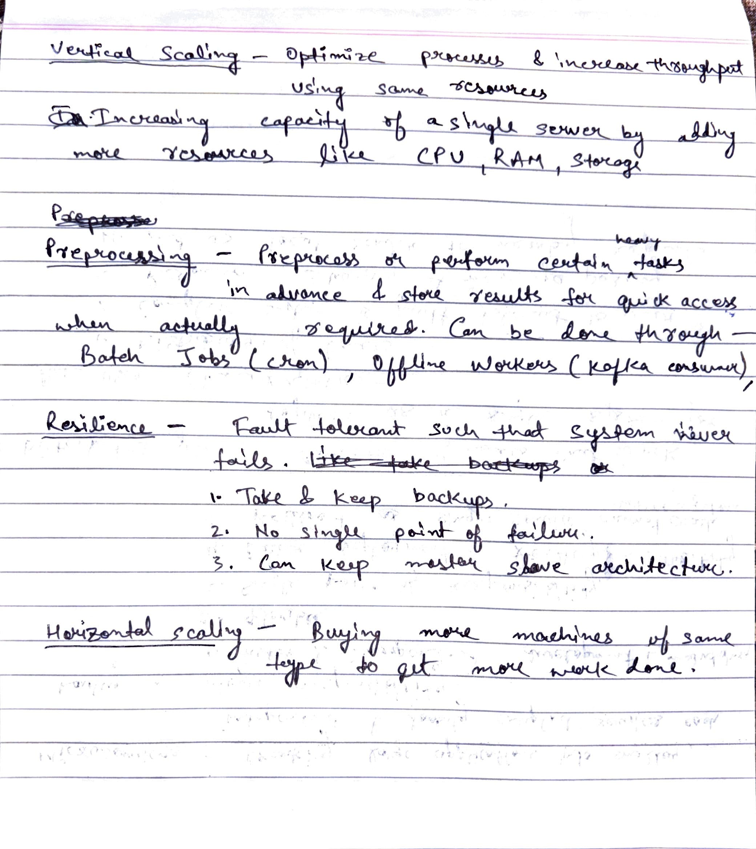

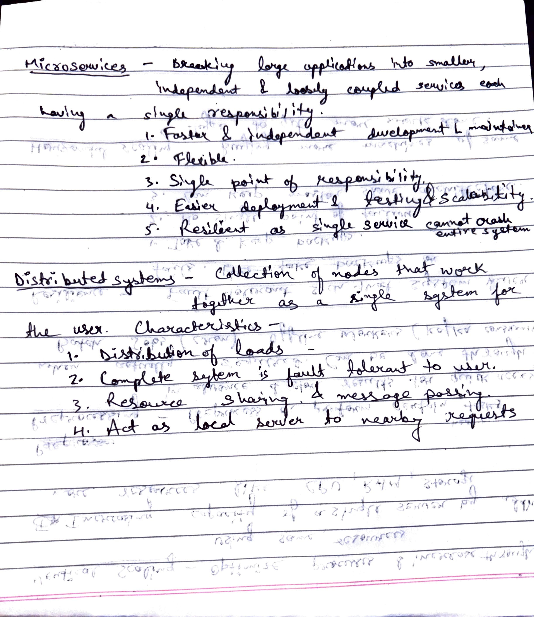

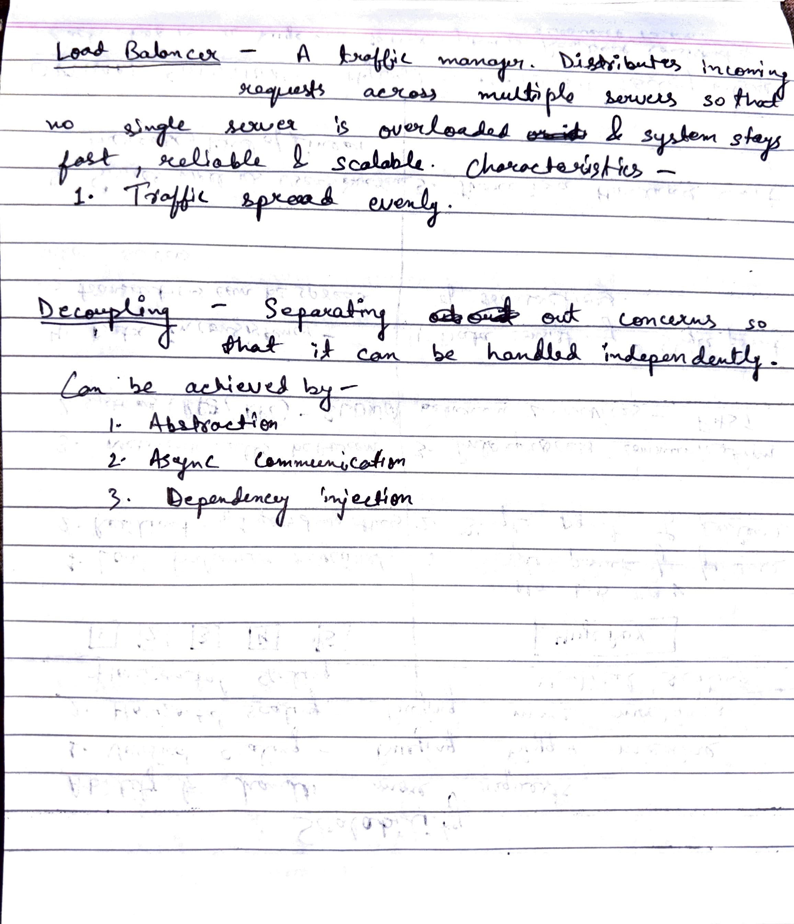

## Avoiding Single Point of Failures

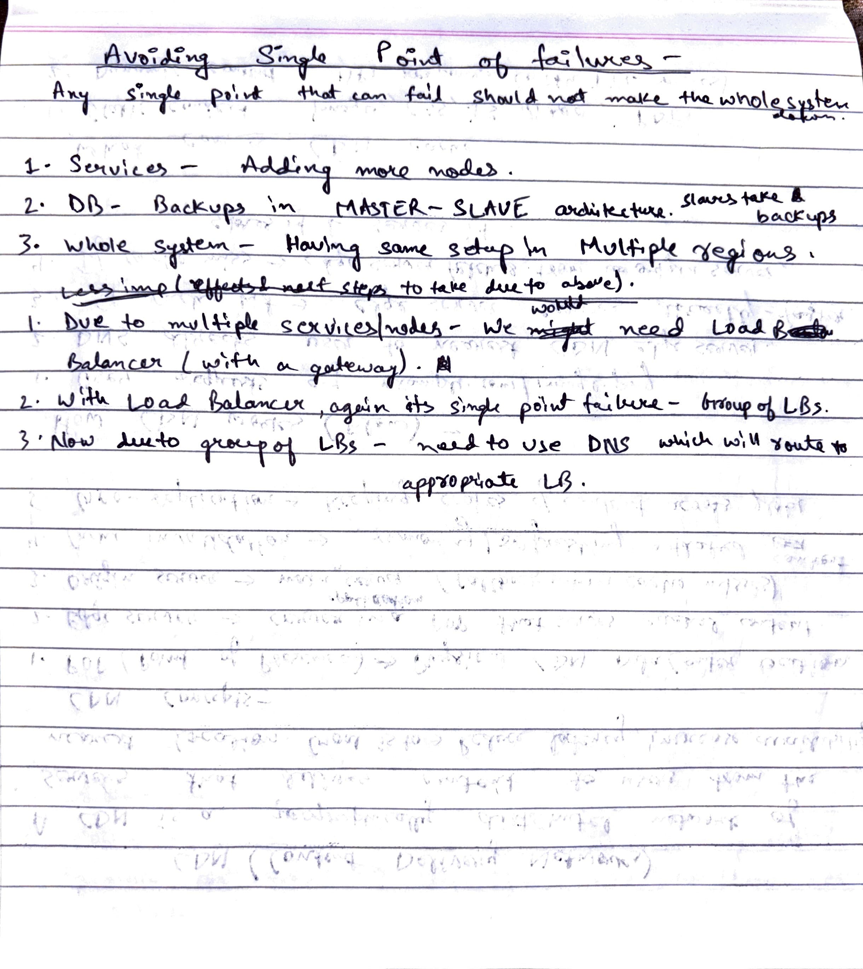

## Scalability in distributed systems

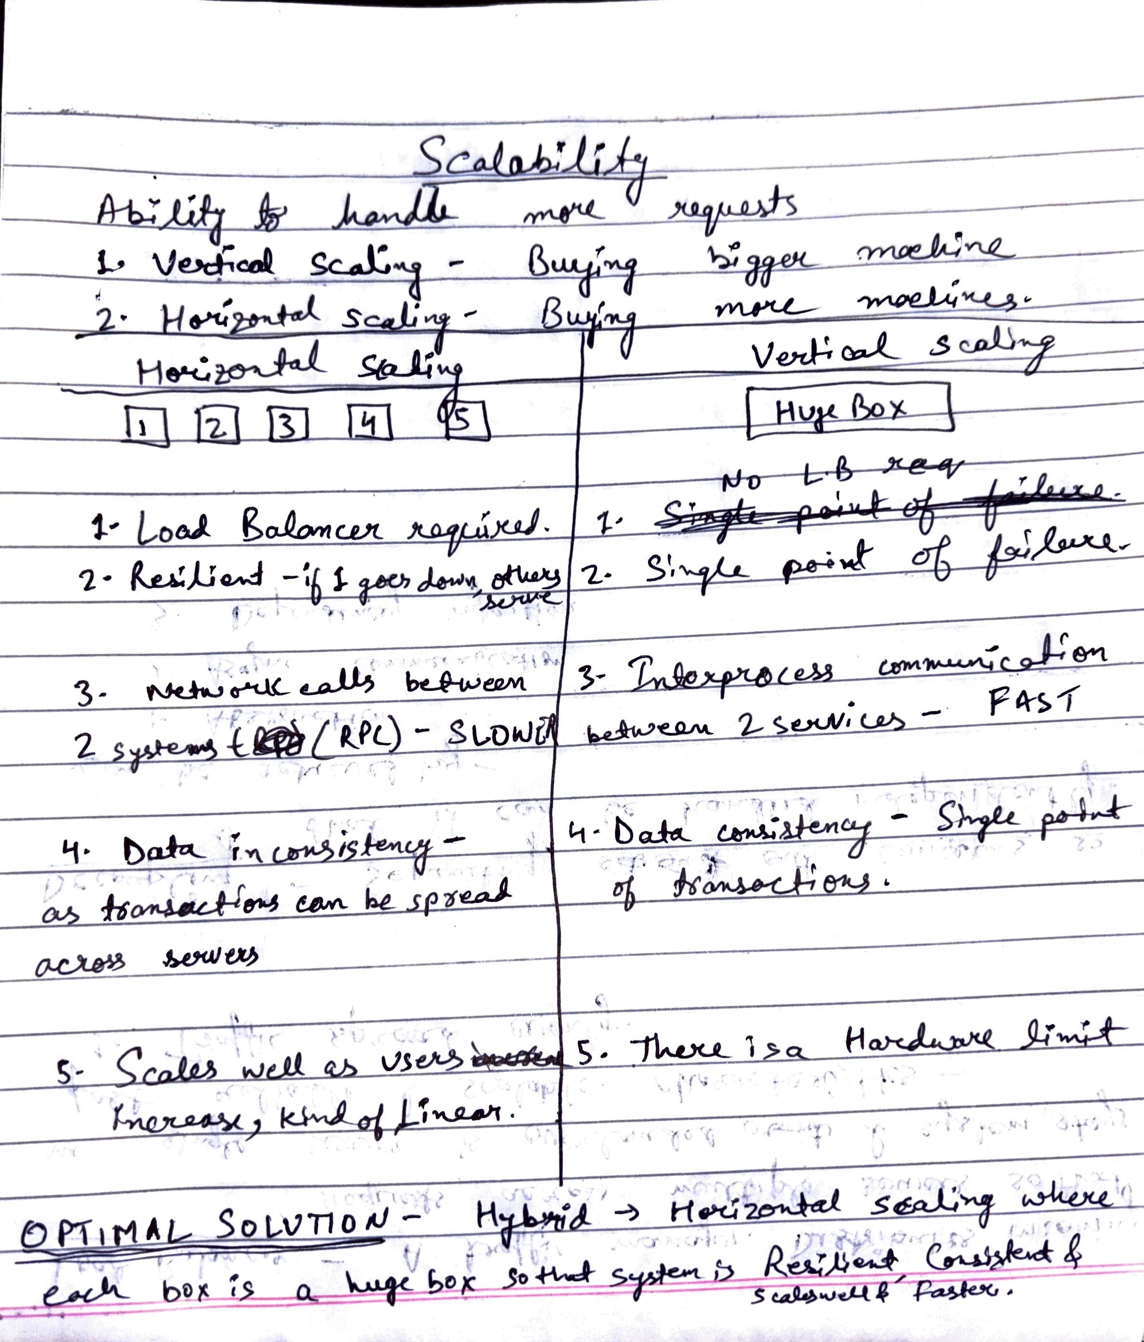

## Replication in Distributed Systems

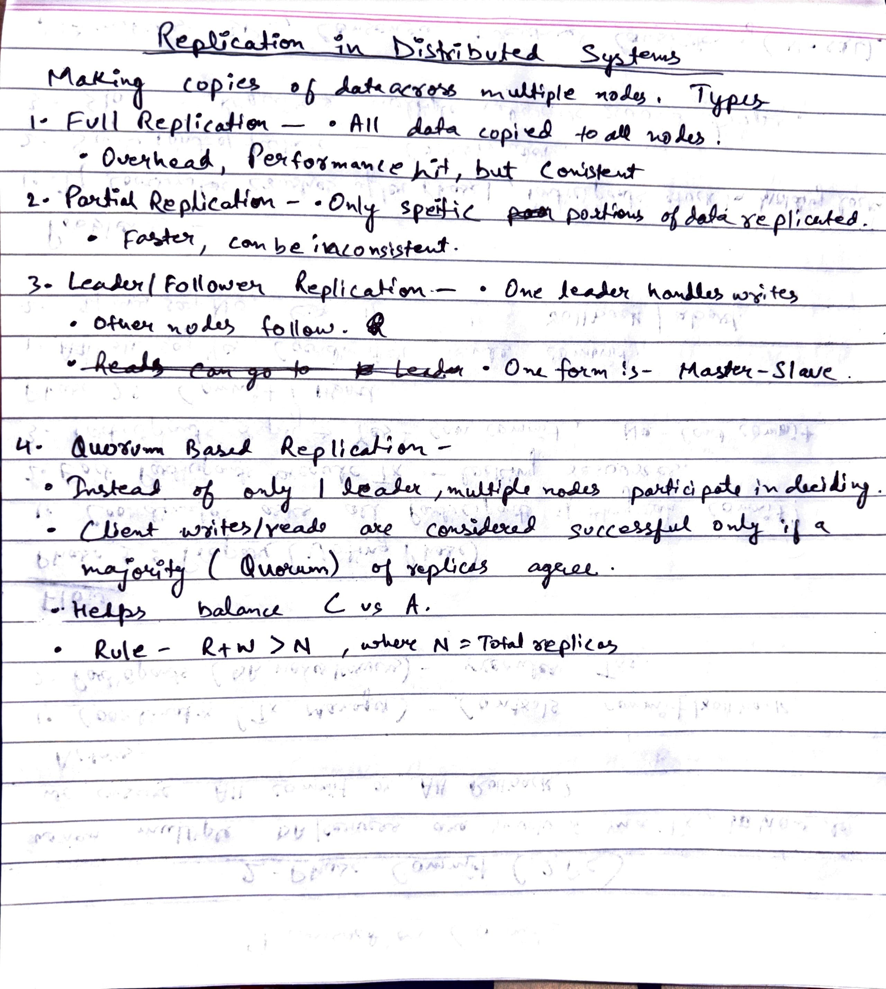

# Architectures

## Client–Server Architecture

A client–server architecture is a model where multiple clients (users, applications, or devices) request services or resources from a centralized server.

* The server hosts, manages, and provides resources (like data, files, computation).
* The client initiates communication by sending a request, and the server responds.

Key Characteristics

1. Two main entities: Client (consumer) and Server (provider).
2. Request–Response model: Client sends a request → Server processes → Server sends back response.
3. Centralization: The server is typically a central authority/resource holder.
4. Scalability: Can scale vertically (more power to the server) or horizontally (multiple servers with load balancers).
5. Examples
   1. Web applications: Browser (client) ↔ Web server (server).
   2. Email: Outlook/Gmail client ↔ Mail server.
   3. Database access: Application ↔ Database server.
6. Advantages
   1. Centralized management (easier to maintain).
   2. Clients don’t need to handle heavy processing — offloaded to server.
   3. Security and backups can be centralized.
7. Disadvantages
   1. Single point of failure: If server goes down, all clients are affected.
   2. Scalability challenges: Too many clients can overload a single server.
   3. Network dependency (client can’t function offline).
8. Evolution
   1. Early days: Single server handling requests.
   2. Modern times: Evolved into multi-tier (3-tier) and distributed architectures (microservices, service mesh).

## 3-Tier Architecture

A 3-tier architecture is a client–server architecture where the application is split into below layers where each tier runs on a separate system or process, communicating via well-defined protocols (usually HTTP, JDBC, etc.):

1. Presentation Layer (UI)
   1. user interface or the “client-facing” part.
   2. Examples: Web browser, mobile app, React/Angular frontend.
   3. Responsible for displaying data and collecting user input.
2. Application Layer (Business Logic)
   1. The “brain” of the system.
   2. processes requests, rules, workflows, authentication, authorization.
   3. Example: Spring Boot, Node.js, Django services.
3. Data Layer (Database)
   1. stores and retrieves data and transactions.
   2. Example: MySQL, PostgreSQL, MongoDB.
4. Advantages
   1. Separation of concerns → Easier to maintain & scale independently.
   2. Scalability → App layer and DB can scale differently.
   3. Security → DB is never directly exposed to client.
   4. Flexibility → Different tech stacks for each layer (React + Java + MySQL).
5. Disadvantages
   1. More complexity than 2-tier (needs networking, deployment setup).
   2. Performance overhead due to extra hops.
   3. Debugging is harder across multiple layers.
6. Evolution
   1. 2-tier (Client ↔ DB) → tightly coupled, hard to scale.
   2. 3-tier solved coupling and introduced separation.
   3. Now extended into n-tier & microservices, where the application layer itself is decomposed into multiple small services.

## Microservices Architecture

Microservices architecture is a style where a large application is broken into a collection of small, loosely coupled services. Each service is:

* Independent (can be developed, deployed, and scaled on its own).
* Owns its own data (separate database or schema).
* Communicates with other services via APIs (HTTP/REST, gRPC, or messaging queues like Kafka/RabbitMQ).

1. Structure
   1. Client (Presentation Layer) – same as before (web, mobile).
   2. API Gateway – entry point that routes requests to the correct microservice.
   3. Microservices – each handling a domain like Auth Service, Cart Service, Order Service
   4. Database per Service – avoids tight coupling.
   5. Messaging/Event Bus (optional) – for asynchronous communication (Kafka, RabbitMQ).
2. Advantages
   1. Scalability – scale hot services (e.g., Payment) without scaling everything.
   2. Agility – teams work independently on different services.
   3. Fault Isolation – failure in one service (e.g., Notifications) doesn’t bring down the entire app.
   4. Technology Flexibility – each service can use different tech (Java, Node.js, Python).
   5. Faster Deployment – small services can be deployed independently (CI/CD).
3. Disadvantages
4. Complexity – distributed system problems (network latency, retries, failures).
5. Operational Overhead – need service discovery, monitoring, logging, tracing.
6. Data Management – difficult to keep data consistent across services.
7. Testing is harder – end-to-end testing across multiple services.
8. DevOps dependency – requires containerization (Docker, Kubernetes).

## Event-Driven Architecture (EDA)

An event-driven architecture is a design pattern where the system is built around events. An event = a significant change in state (e.g., UserRegistered, OrderPlaced, PaymentProcessed). Instead of direct service-to-service calls, services publish events and other services subscribe to those events.

1. Core Components
   1. Event Producer – generates/publishes events (e.g., Order Service publishing OrderPlaced).
   2. Event Broker – middleware that routes events (e.g., Kafka, RabbitMQ, AWS SNS/SQS).
   3. Event Consumer – listens for events and reacts (e.g., Notification Service sends email when OrderPlaced is received).
2. Types of Event-Driven Communication
   1. Point-to-Point (Queue)
      1. One producer → one consumer.
      2. Example: Order placed → Payment service (only one service consumes).
   2. Publish/Subscribe (Topic)
      1. One producer → multiple consumers.
      2. Example: Order placed → Inventory, Payment, Notification all consume.
3. Advantages
   1. Loose Coupling – producers don’t care who consumes.
   2. Scalability – consumers can scale independently.
   3. Asynchronous – services don’t block waiting for responses.
   4. Extensibility – adding a new service (e.g., Analytics) is easy, just subscribe.
   5. Resilience – if one consumer is down, events can be replayed later (depending on broker).
4. Disadvantages
   1. Eventual Consistency – data isn’t updated instantly everywhere.
   2. Debugging/Tracing is hard – hard to track an event’s journey across services.
   3. Message Duplication – consumers must handle duplicate events.
   4. Complexity – requires strong monitoring, dead-letter queues, retries.
5. When to Use
   1. High scale, decoupled systems.
   2. Event-heavy applications:
   3. E-commerce (OrderPlaced → Payment, Inventory, Shipping).
   4. IoT (sensors generating events).
   5. Logging & monitoring pipelines.
   6. Real-time systems (stock trading, chat apps).

## Peer-to-Peer (P2P) Architecture

In P2P architecture, there is no central server. Every node (called a peer) acts as both: Client (requesting resources) and Server (providing resources). Responsibility is distributed across peers.

1. Examples
   1. File sharing: BitTorrent, eMule.
   2. Messaging: Early Skype (before moving to more centralized infra).
   3. Blockchain/cryptocurrency: Bitcoin, Ethereum.
2. Advantages
   1. No single point of failure – network continues even if some peers fail.
   2. Scalability – more peers joining = more resources.
   3. Cost-effective – no central server needed.
   4. Self-organizing – peers can dynamically join/leave.
3. Disadvantages
   1. Data consistency issues – keeping all peers updated is hard.
   2. Security risks – every peer is exposed, making it harder to enforce trust.
   3. Performance variability – depends on peers’ availability & bandwidth.
   4. Difficult monitoring/management – no central control point.
4. Types of P2P
   1. Unstructured P2P
      1. Peers randomly connect.
      2. Example: Gnutella, early P2P networks.
      3. Pros: Easy to join.
      4. Cons: Searching for data is inefficient (flood queries).
   2. Structured P2P
      1. Uses a specific topology and algorithms like Distributed Hash Tables (DHTs).
      2. Example: BitTorrent, Kademlia.
      3. Pros: Efficient searching & routing.
      4. Cons: More complex to implement.
5. When to Use P2P
   1. File distribution (large files, many users → torrenting).
   2. Blockchain (needs decentralization & fault tolerance).
   3. Collaborative apps (real-time P2P gaming, messaging, IoT).

## Serverless Architecture

Serverless does not mean there are no servers — it means developers don’t manage servers directly. Cloud providers (AWS, Azure, GCP) manage infrastructure, scaling, and maintenance. Developers just write functions (called FaaS – Function as a Service) or use managed services, and the cloud runs them on demand.

1. How It Works
   1. The developer writes small independent functions (e.g., processPayment()).
   2. Function is deployed to a cloud provider.
   3. The function is triggered by an event (HTTP request, DB update, file upload, message in queue).
   4. Cloud provider:
      1. Allocates compute on demand
      2. Executes the function
      3. Scales automatically
      4. Shuts down when not needed
   5. You only pay for execution time (not idle servers).
2. Examples - AWS Lambda, Azure Functions, Google Cloud Functions.
3. Advantages
   1. No server management – infra handled by cloud.
   2. Scales automatically with load.
   3. Cost-efficient – pay per execution, not 24/7 uptime.
   4. Faster development – focus only on business logic.
   5. Event-driven – integrates easily with APIs, queues, databases.
4. Disadvantages
   1. Cold starts – first request after inactivity is slow.
   2. Limited execution time – functions often capped (e.g., AWS Lambda 15 mins).
   3. Vendor lock-in – tied to provider APIs.
   4. Debugging & monitoring harder – distributed execution across ephemeral instances.
   5. Not suitable for long-running processes (like ML training).
5. Use Cases
   1. Web APIs (REST/GraphQL endpoints)
   2. Data processing (image resize, log processing).
   3. Real-time notifications (IoT, chat, push notifications).
   4. Scheduled jobs (cron-like tasks).
   5. Event-driven workflows (payment → notification → email).

## Monolith vs Microservice

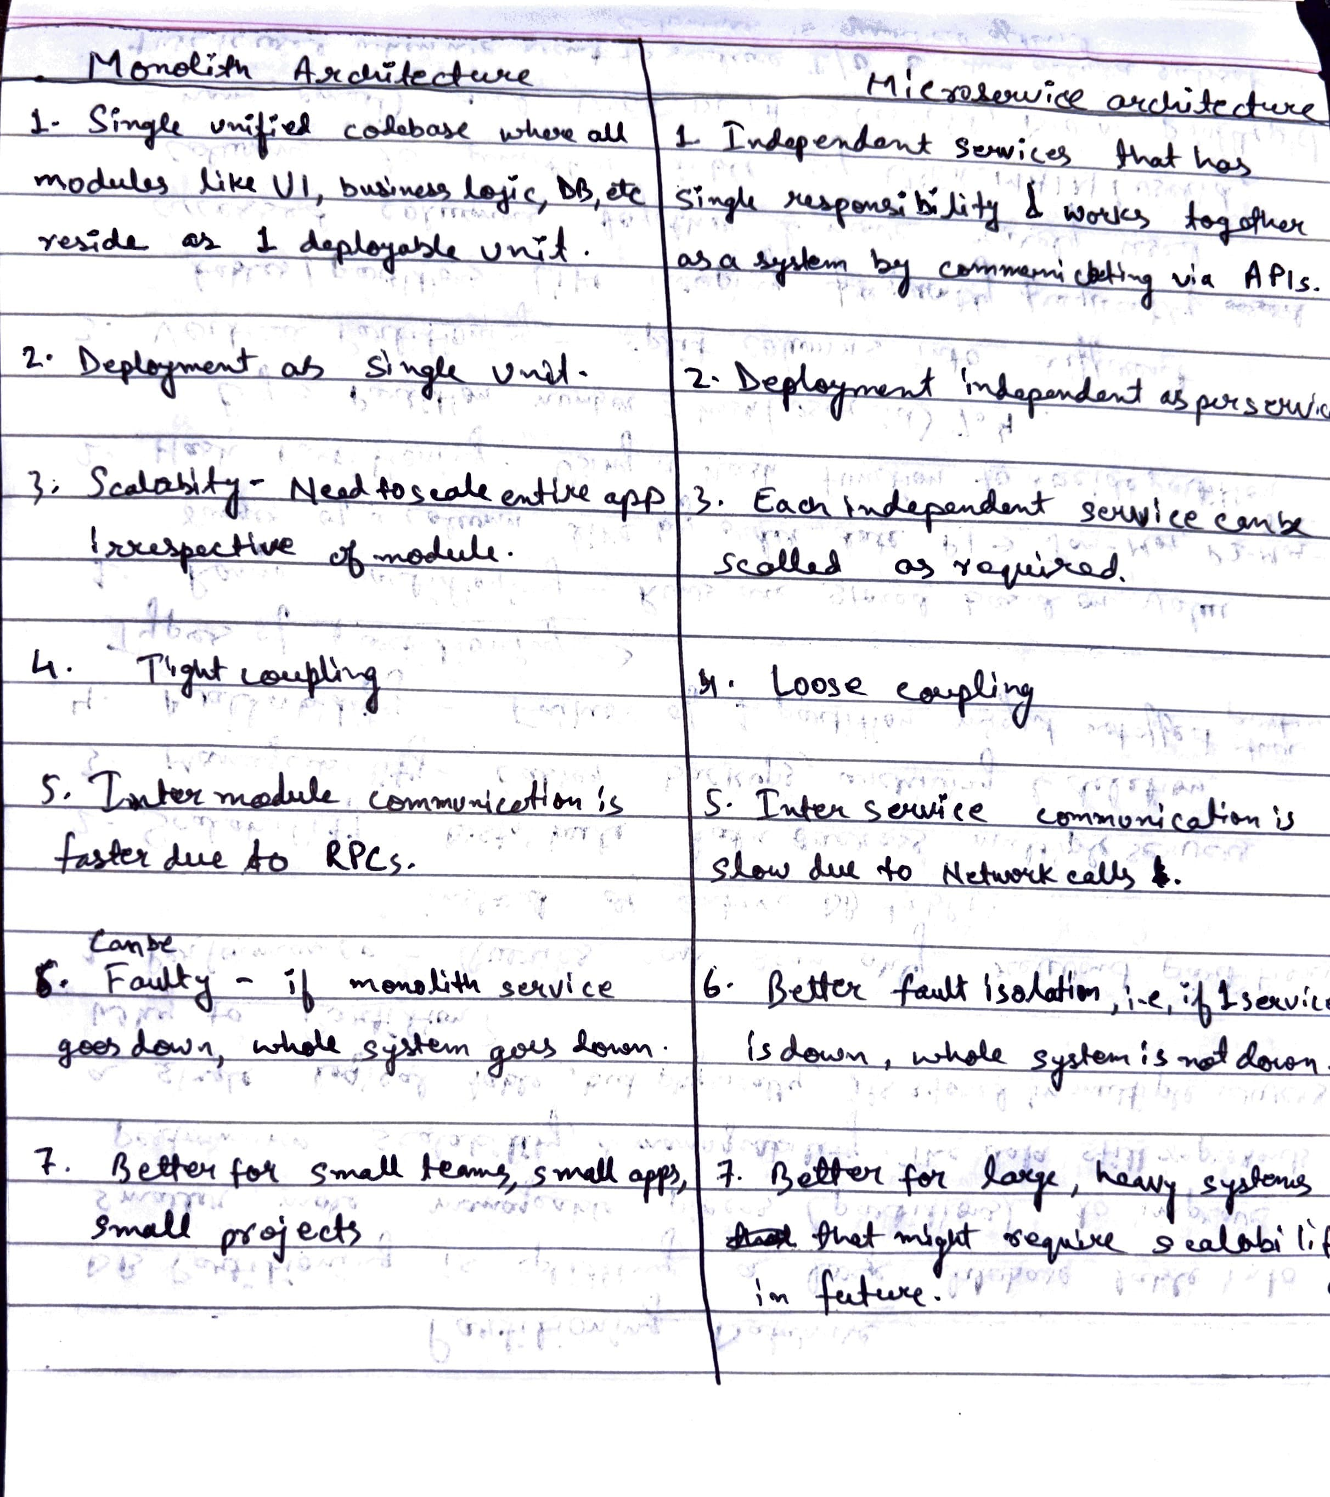

# Distributed Coordination

## CAP Theorem

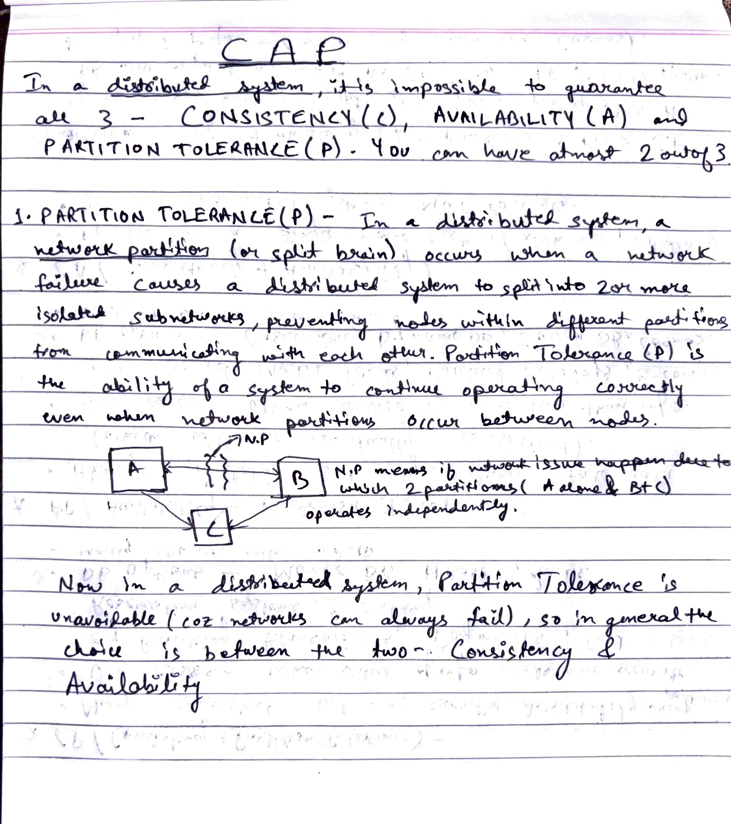

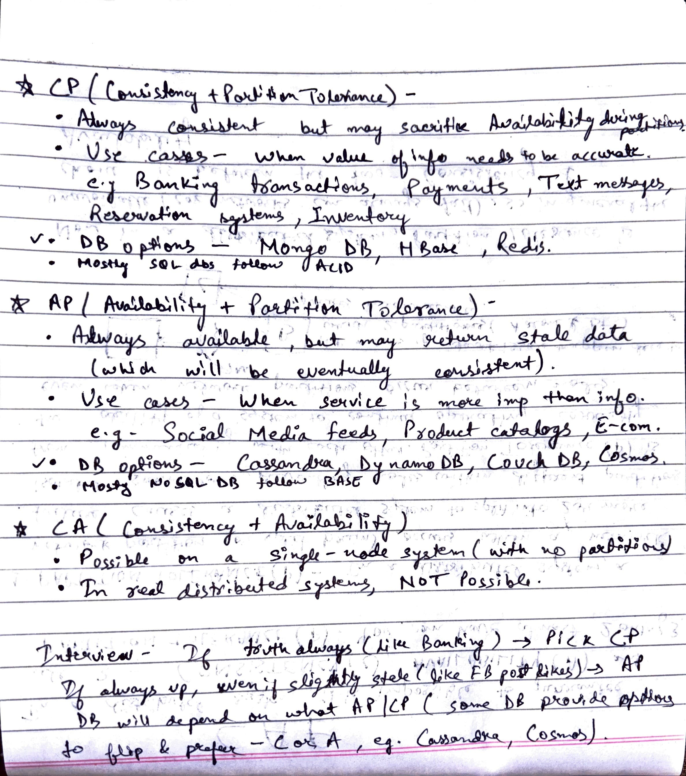

## Consistent Hashing

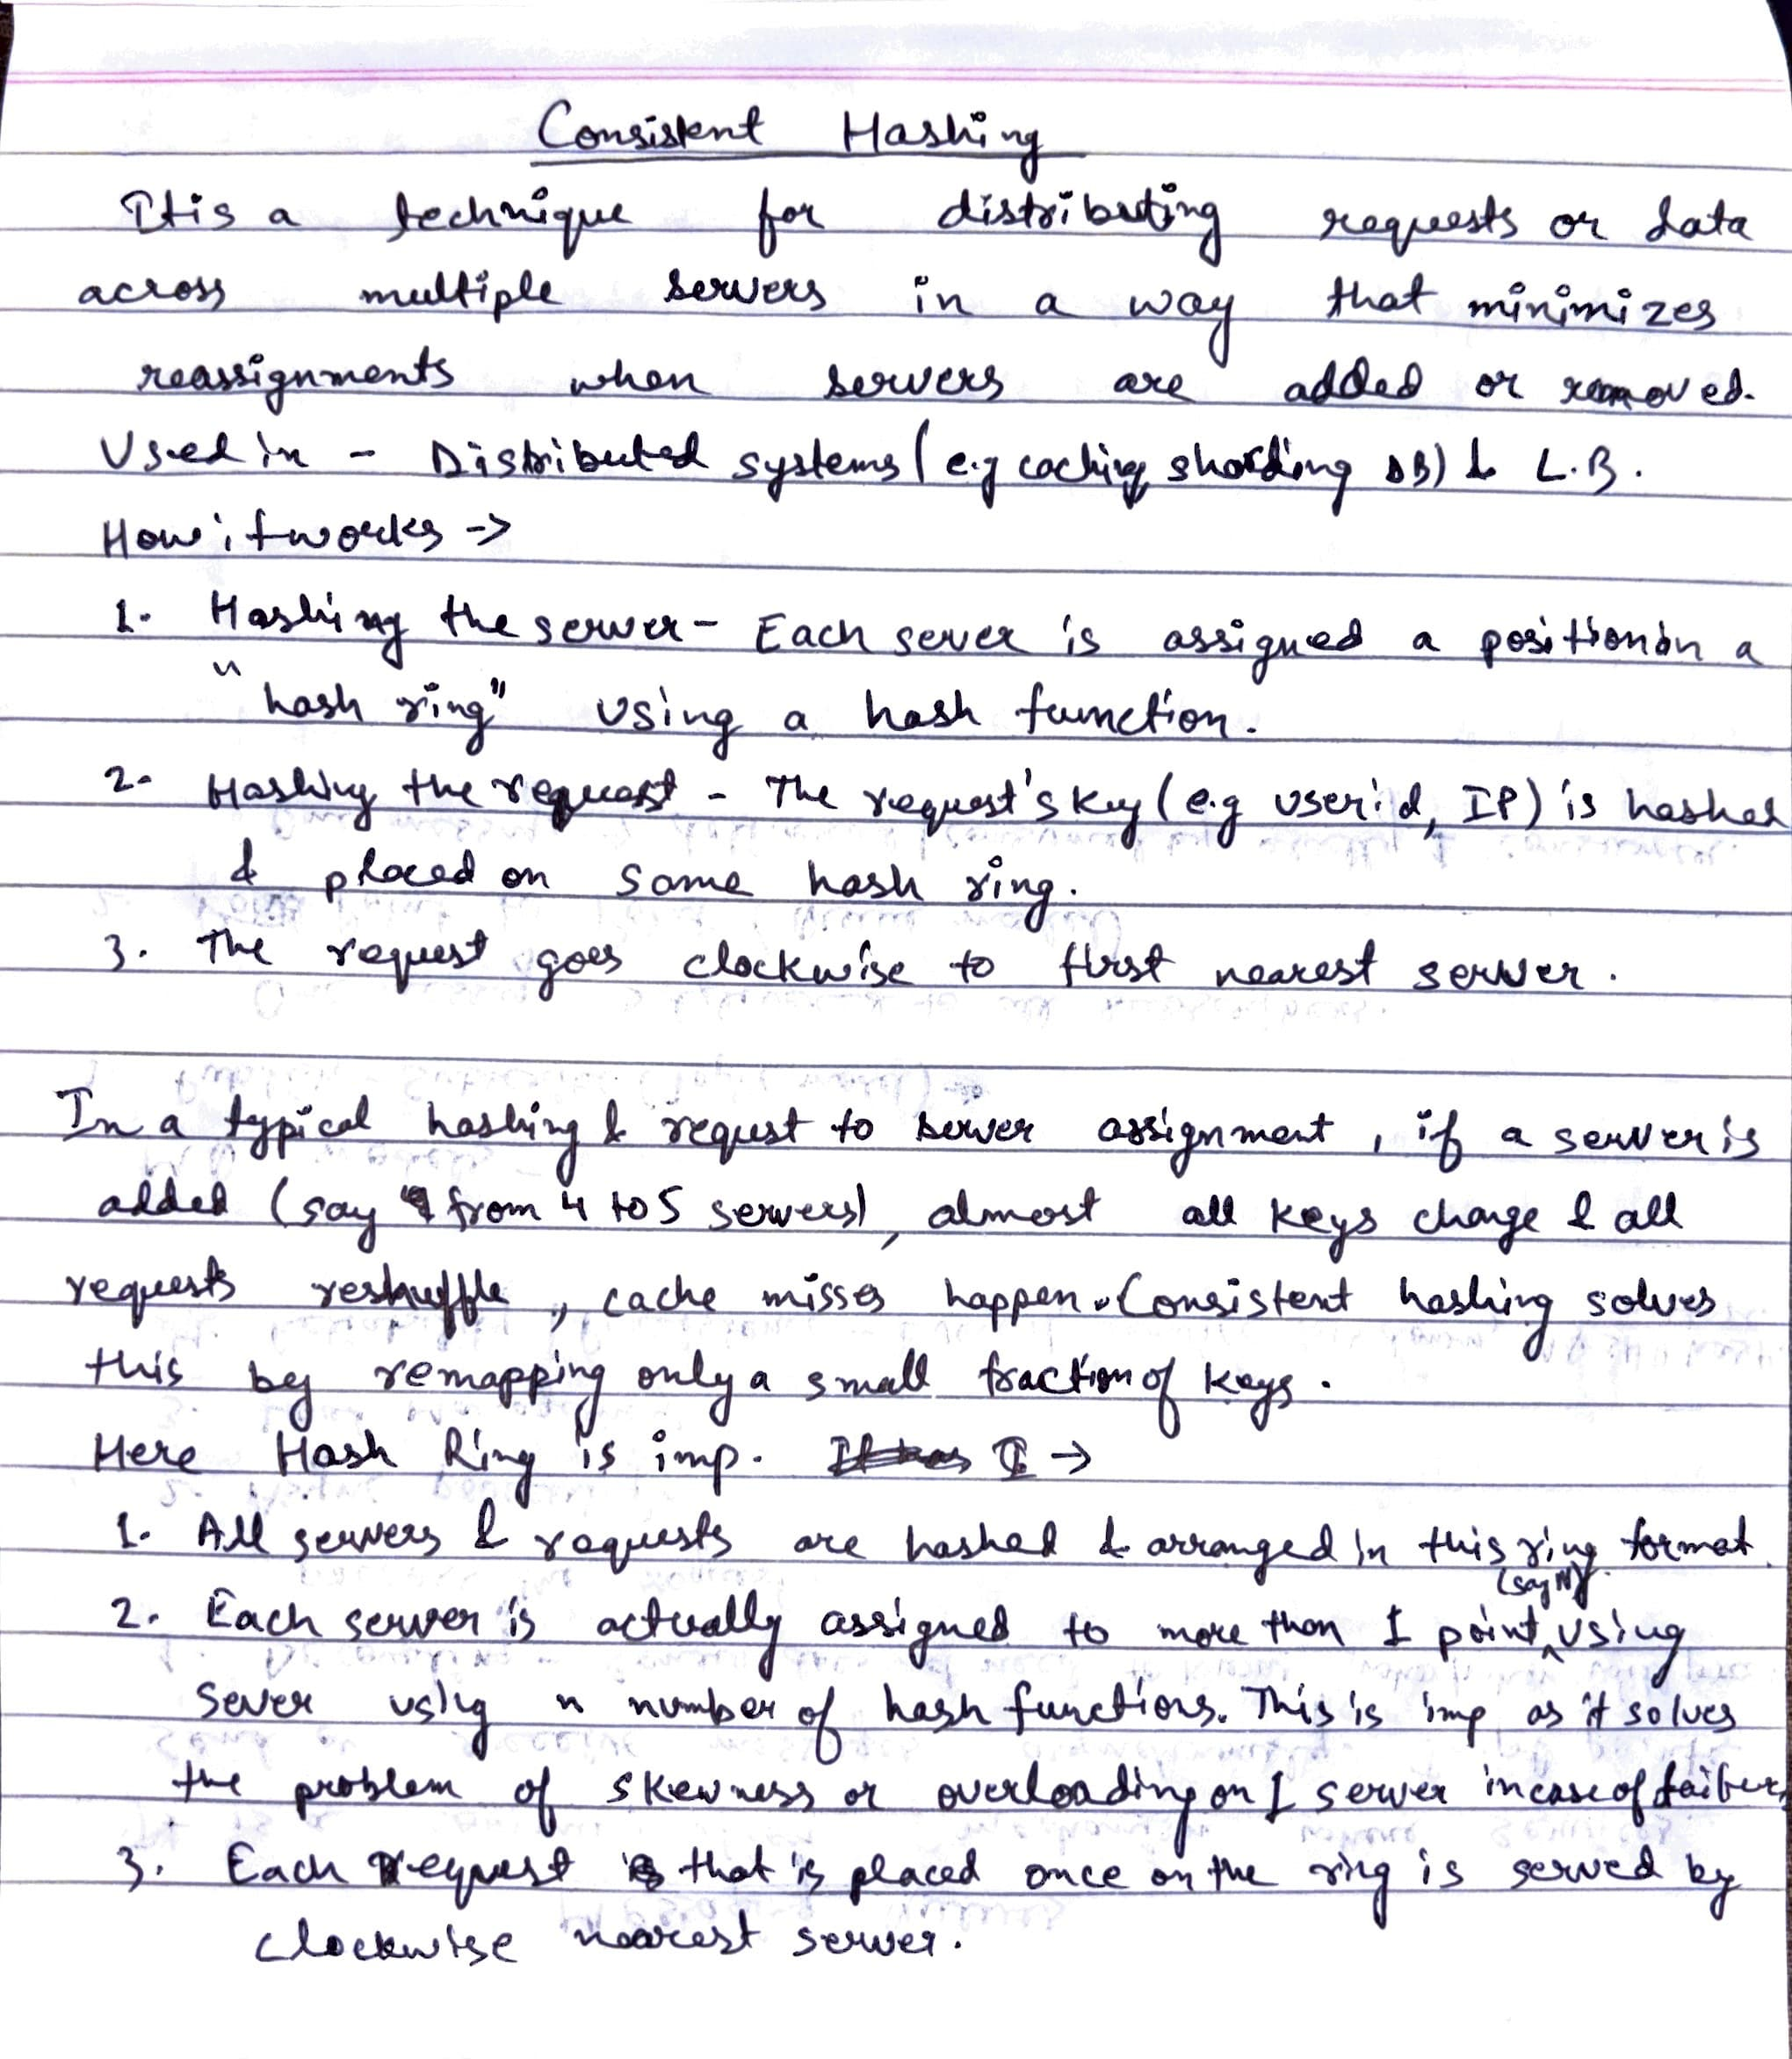

## Gossip Protocol

The Gossip Protocol (also called epidemic protocol) is a peer-to-peer communication mechanism used in distributed systems to spread information (like cluster membership, state, or updates) in a way that mimics how gossip spreads in real life.

Instead of one central node telling everyone, each node randomly picks another node and shares what it knows. Over time, information “infects” the entire network.

Key Ideas:

1. Randomized communication:
   * Each node periodically selects a random peer and exchanges state.
   * Information spreads gradually but quickly.
2. Eventually consistent:
   * Not all nodes are updated at the same time, but eventually the entire cluster converges to the same state.
3. Scalability & fault-tolerance:
   * No central coordinator, so even if some nodes fail, the gossip continues.
   * Works well in large-scale distributed systems.
4. Strengths:
   * Scalable, decentralized, fault-tolerant, low-overhead.
5. Weaknesses:
   * Eventual consistency (not instant), redundant messages.

Where is the Gossip Protocol used?

* Cluster membership & failure detection → Used in systems like Cassandra, DynamoDB, Akka, Consul to keep track of which nodes are alive.
* Data replication & consistency → Spreads updates about data across nodes.
* Leader election support → Helps nodes detect failures and elect a new leader.

## Consensus Algorithms

In a distributed system, multiple nodes (servers) must agree on a single value/state, even if some nodes fail or give conflicting info.

Consensus = “agreeing on the truth in a cluster of machines.”

Without consensus → different nodes may “think” differently → chaos.

Why is it needed?

1. Leader Election → Who is the master/leader?
2. Consistency of data → All replicas agree on updates.
3. Fault Tolerance → Even if some nodes crash, the system continues.

Main Algorithms -

1. Paxos
   1. The earliest well-known algorithm.
   2. Ensures consensus even if some nodes fail.
   3. Very theoretical & complex (not widely implemented directly).
   4. Key roles: Proposer, Acceptor, Learner.
   5. Works via multiple rounds of proposals until majority agrees.
   6. Known as correct but too hard to implement in real-world systems.
2. Raft
   1. Created later as a more understandable alternative to Paxos.
   2. Most modern distributed systems (etcd, Consul, Kafka’s controller election) use Raft.
   3. Key steps:
      1. Leader Election → Cluster picks a leader node.
      2. Log Replication → Leader appends commands to log, replicates to followers.
      3. Safety → Only committed entries are applied.
   4. Easier to explain → widely used in practice.
3. Zab (Zookeeper Atomic Broadcast)
   1. Used in Apache Zookeeper (coordination service).
   2. Similar to Raft but tailored for Zookeeper’s needs.

## Service Discovery

In microservices, services run on multiple hosts/containers and their IPs/ports may change dynamically (due to scaling, failures, or restarts). Service Discovery is the mechanism by which services automatically find and communicate with each other without hardcoding addresses.

Two main types of Service Discovery

1. Client-Side Service Discovery
   1. How it works:
      1. The client is responsible for finding the service location.
      2. The client queries the Service Registry (like Eureka, Consul, Zookeeper) to get the list of available instances.
      3. The client then applies load balancing logic (e.g round robin, weighted)
      4. Finally, the client directly calls the chosen service instance.
   2. Flow Example: Order Service → queries Eureka → gets IP:Port of Payment Service instance → calls it directly.
   3. Pros
      1. Simple, no need for an extra network hop (client talks directly to service).
      2. Clients can implement smart load balancing.
   4. Cons
      1. Every client must have service discovery + load balancing logic built in.
      2. Harder to update logic in many clients (tight coupling).
   5. Examples:
      1. Netflix Eureka + Ribbon (Java clients).
      2. Consul client-side discovery libraries.
2. Server-Side Service Discovery
   1. How it works:
      1. The client does not query the registry directly.
      2. Instead, the client sends the request to a load balancer or proxy.
      3. The load balancer queries the service registry, picks a healthy instance, and forwards the request.
   2. Flow Example: Order Service → calls Load Balancer (e.g., AWS ELB) → LB queries Consul → LB forwards to Payment Service instance.
   3. Pros
      1. Clients are simple (they just call one endpoint).
      2. Centralized load balancing logic.
      3. Easier to manage in large heterogeneous environments.
   4. Cons
      1. Adds extra network hop (client → load balancer → service).
      2. Load balancer could be a single point of failure (though usually made redundant).
   5. Examples:
      1. AWS Elastic Load Balancer, NGINX + Consul.
      2. Kubernetes Service (ClusterIP, NodePort, Ingress → kube-proxy acts as load balancer).

Components of Service Discovery

1. Service Registry

* A central database where services register themselves when they start, and deregister when they stop.
* Examples: Eureka, Consul, Zookeeper, etcd.

2. Health Checking

* Ensures only healthy instances are discoverable.

3. Load Balancing

* Distributes requests among available instances.

Why is Service Discovery needed?

Without it:

* Services must hardcode IPs/ports of other services → brittle.
* Scaling and dynamic orchestration (Kubernetes, Docker) would break things.

With it:

* Services just call “UserService”, registry resolves to correct IP/port.

# Communication and APIs

## REST vs GraphQL vs RPC

|  |  |  |  |
| --- | --- | --- | --- |
| **Aspect** | **REST** | **GraphQL** | **RPC (e.g., gRPC, Thrift)** |
| Definition | API style using resources (/users/1) and HTTP verbs (GET, POST, etc.) | Query language for APIs where clients specify exactly what data they need | Remote Procedure Call – invokes methods on a remote server as if local |
| Data Model | Resource-oriented (nouns: /users, /orders) | Flexible, strongly-typed schema with queries & mutations | Function/method-oriented (getUser(id)) |
| Transport | Mostly HTTP/HTTPS | HTTP/HTTPS (typically POST) | HTTP/2 (commonly) or custom protocols |
| Payload Format | JSON (usually) | JSON response (client decides fields) | Protocol Buffers (gRPC), Thrift, Avro → compact binary |
| Over-fetching / Under-fetching | Common (fixed endpoints return too much or too little data) | Avoided (client specifies exact fields) | Not an issue (methods return what is defined) |
| Performance | Can require multiple round trips (e.g., fetch user, then orders) | Single query can fetch nested data in one request | Very efficient (binary serialization, multiplexed streams in gRPC) |
| Schema | Not enforced by default (can use OpenAPI/Swagger) | Strongly typed schema with introspection | Strict interface definition (IDL like .proto in gRPC) |
| Ease of Use | Simple, human-readable, easy to test via browser/curl | Flexible for clients, but needs schema management | Requires code generation, but efficient for machine-to-machine comm. |
| Use Cases | Public APIs, CRUD services, simple web/mobile apps | Client-driven apps (mobile, frontend-heavy apps) | Internal microservices, high-performance backend systems |
| Learning Curve | Low | Medium (requires GraphQL schema + resolvers) | Higher (needs IDL, codegen, binary protocol understanding) |

## WebSocket

A communication protocol providing full-duplex (two-way) communication between client and server over a single TCP connection. Unlike HTTP (request → response), WebSocket allows persistent connection where both client and server can push data anytime.

How it works

1. Starts as an HTTP handshake (client sends request with Upgrade: websocket).
2. Server upgrades the connection → switches protocol from HTTP → WebSocket.
3. Connection stays open until explicitly closed.
4. Data can now flow bi-directionally in real time.

Why WebSocket?

1. HTTP is stateless & client-driven → server can’t push updates unless client keeps polling.
2. Polling = inefficient (lots of wasted requests).
3. WebSocket = efficient real-time communication.

Use Cases

1. Chat applications (WhatsApp Web, Slack).
2. Live notifications (Facebook/Instagram likes, Twitter updates).
3. Stock tickers / Crypto trading dashboards (real-time price updates).
4. Online gaming (low latency, constant communication).
5. Collaborative tools (Google Docs live editing).

WebSocket vs Alternatives

1. Polling: client asks server every X seconds → wasteful.
2. Long Polling: client request kept open until server has data → better, but still costly.
3. Server-Sent Events (SSE): server → client one-way push only.
4. WebSocket: full-duplex, real-time, efficient.

## DNS (Domain Name System)

DNS is like the phonebook of the internet. It translates human-readable domain names (e.g., google.com) into IP addresses (e.g., 142.250.182.78) that computers use to communicate.

Why DNS is Important?

* Users can’t remember IP addresses.
* IPs may change (due to scaling, load balancing, cloud migration).
* DNS makes applications resilient to these changes by keeping the domain name constant.

How DNS Resolution Works

1. User types www.example.com in the browser.
2. The request goes through:
   1. Browser Cache → check if IP is already cached.
   2. OS Cache (local machine).
   3. ISP’s Recursive Resolver → asks multiple servers.
   4. Root DNS Server → points to TLD (.com, .org, etc.).
   5. TLD Server → points to the authoritative name server.
   6. Authoritative DNS Server → final mapping of domain → IP.
3. IP is returned → browser connects to server.

Types of DNS Records

* A Record → Domain → IPv4 address.
* AAAA Record → Domain → IPv6 address.
* CNAME → Alias to another domain.
* MX Record → Mail servers.
* NS Record → Name servers.
* TXT Record → Metadata (SPF, security, verification).

DNS in System Design

* Used in Load Balancing → domain resolves to different IPs (round robin, geo-based).
* CDN → DNS directs users to nearest edge server.
* Service Discovery → microservices may use DNS to find other services.
* Failover → DNS can redirect traffic to backup servers when one is down.

DNS Challenges

* Propagation Delay → DNS updates can take time due to caching.
* Single Point of Failure → If DNS server is down, whole app is unreachable.
* Latency → multiple lookups add time.

# Databases

## SQL vs No-SQL

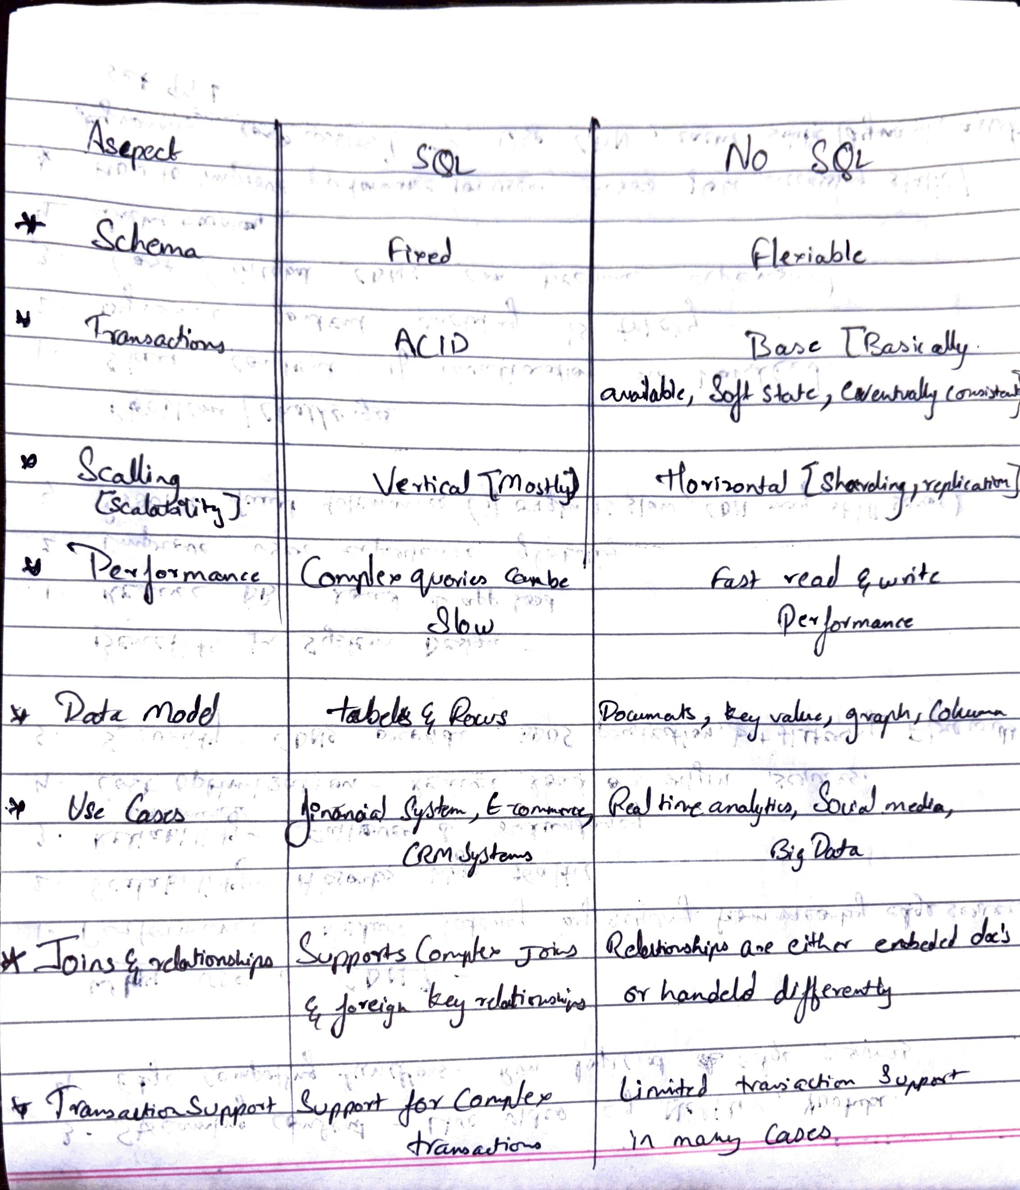

## ACID Transactions

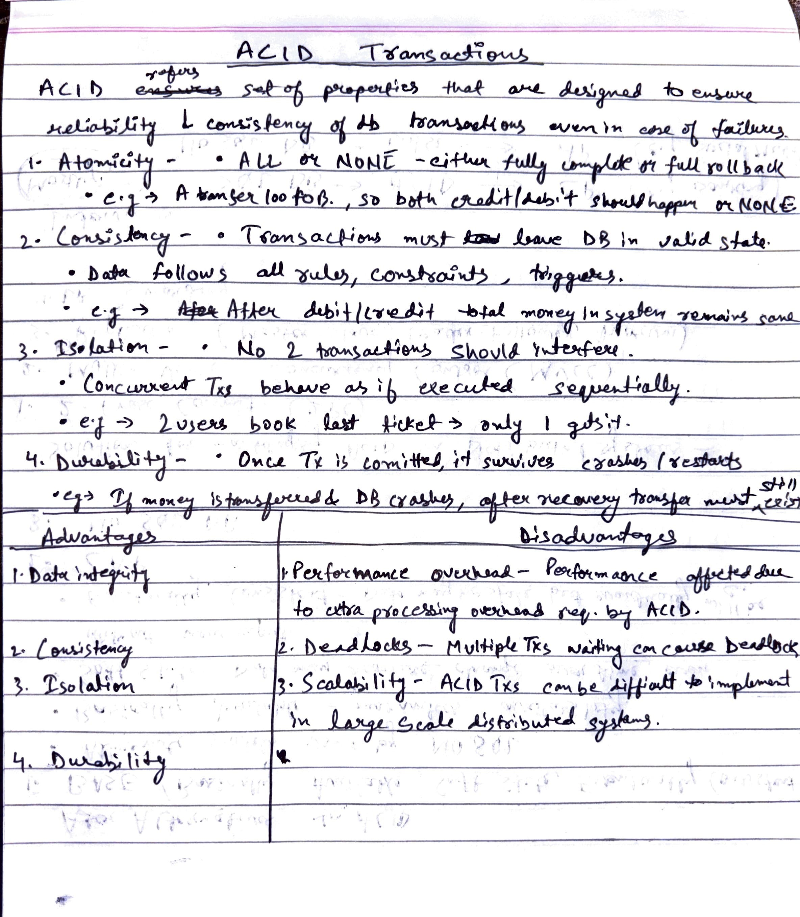

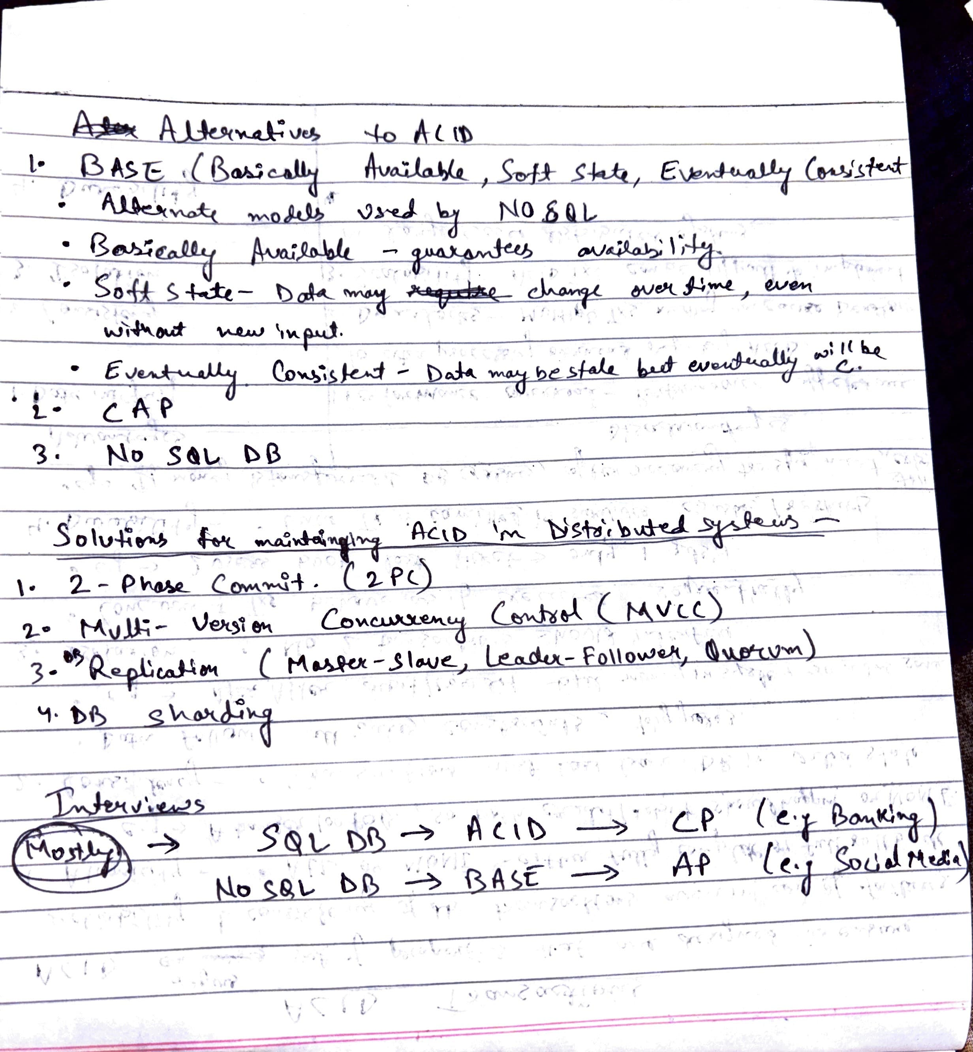

## Partitioning in DB and Sharding

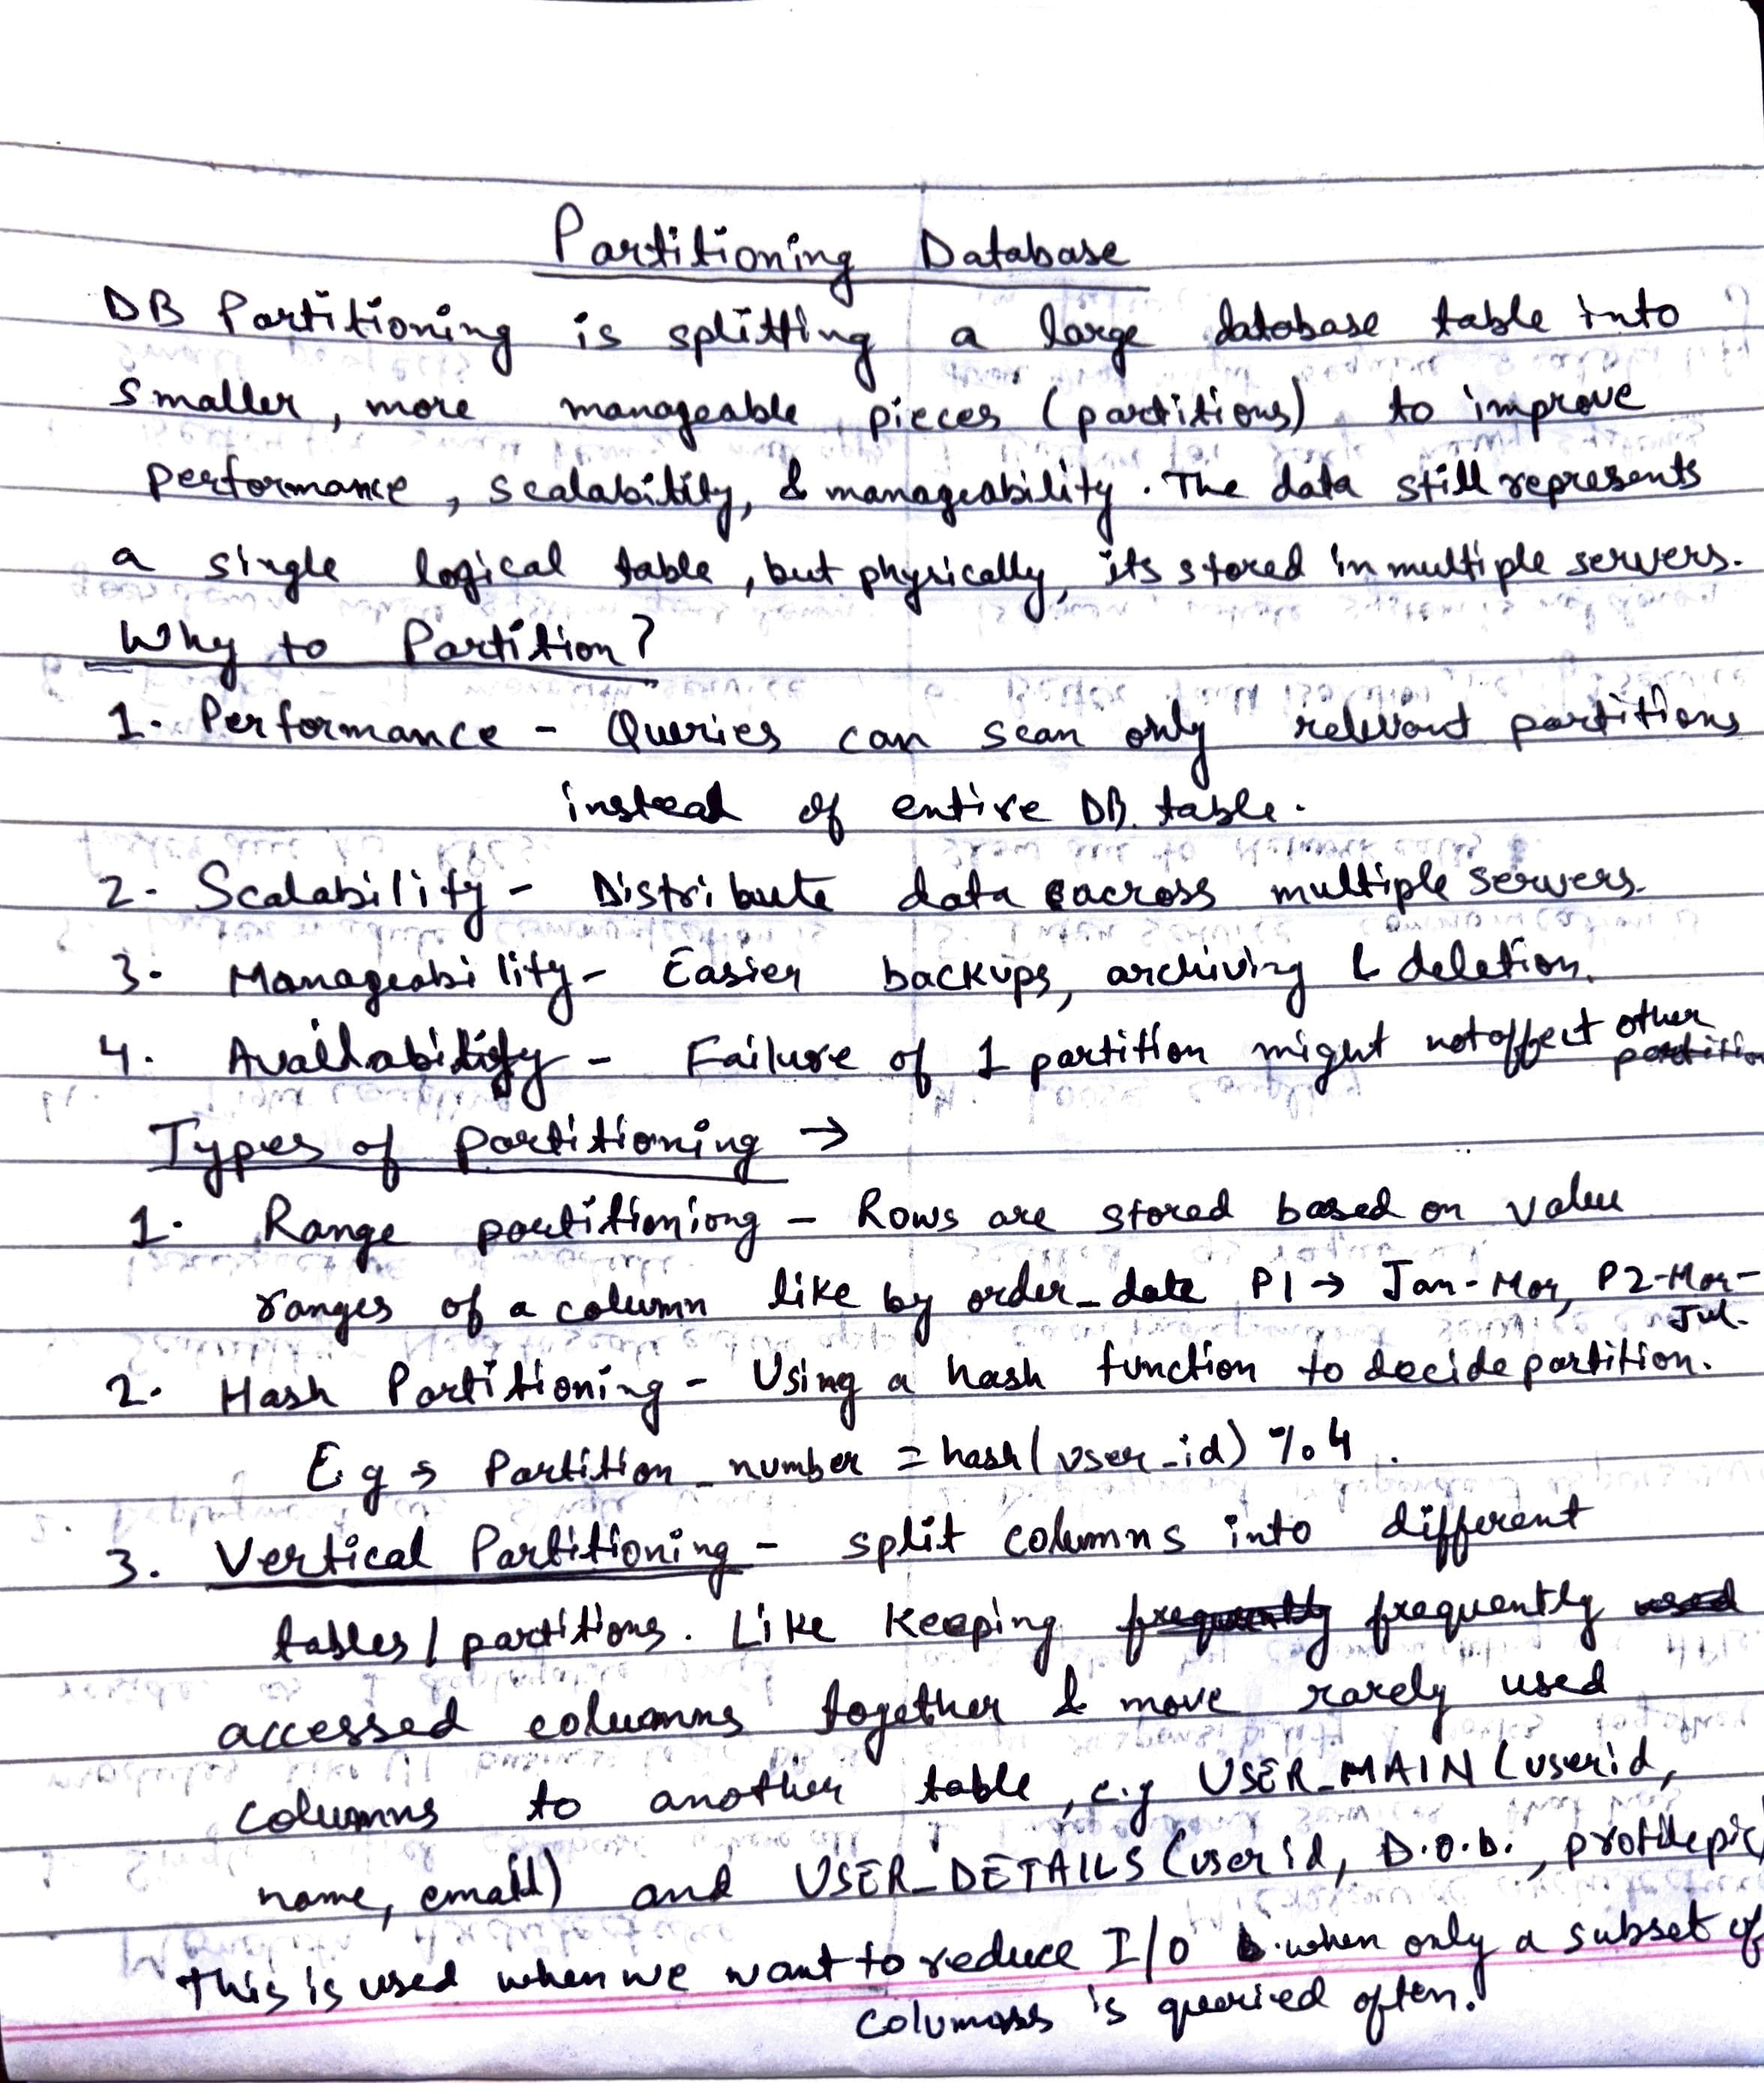

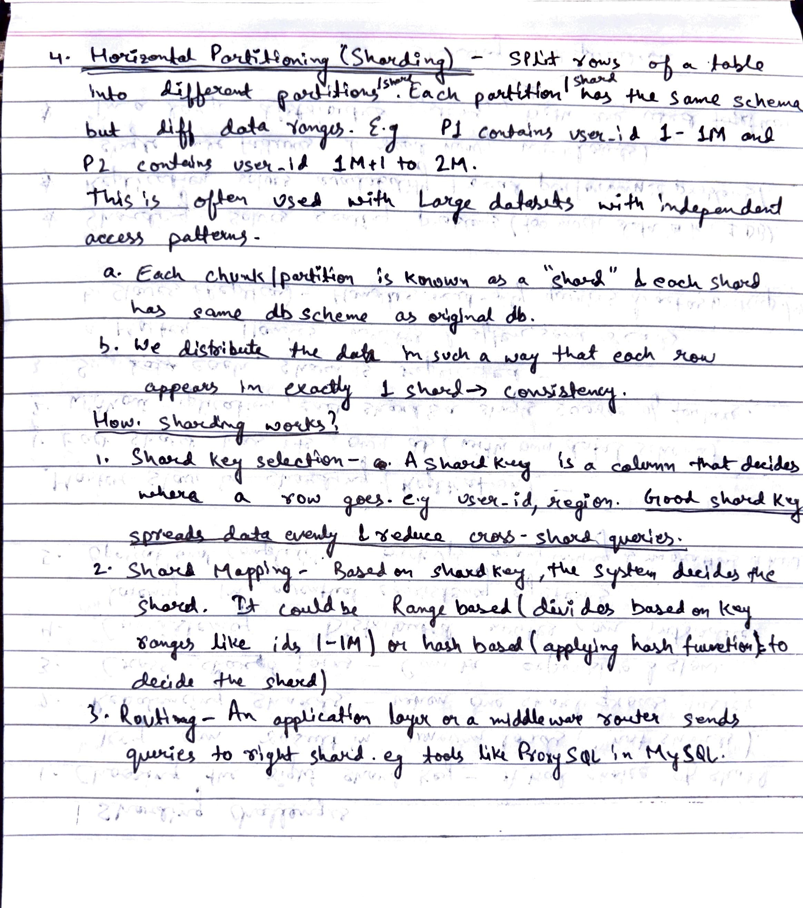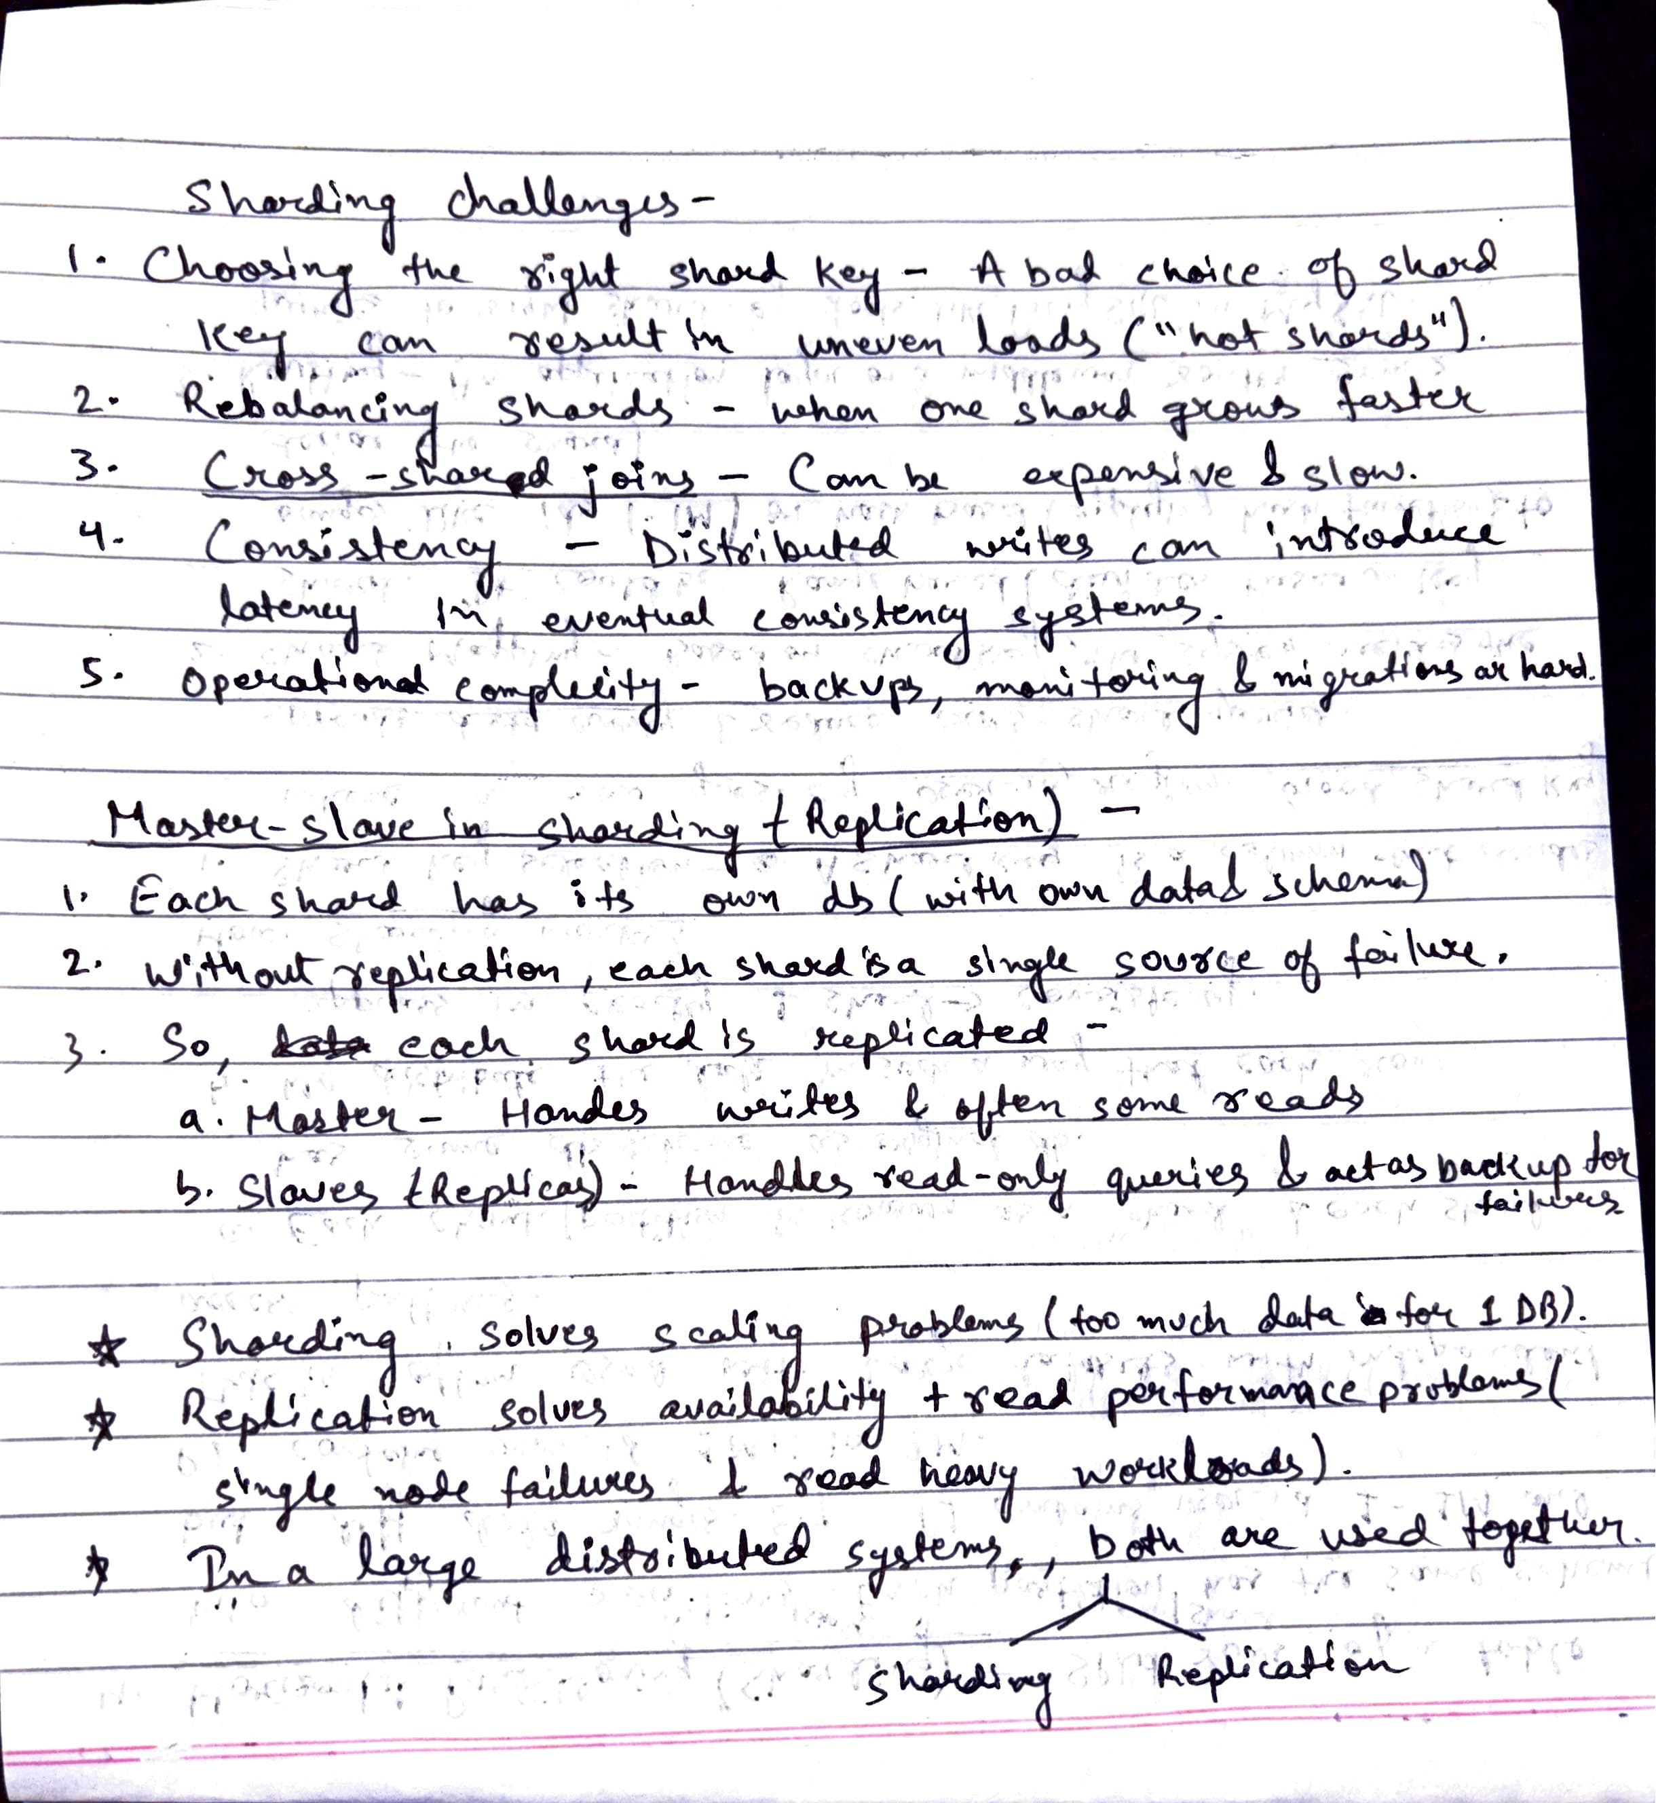

## Transaction Commits

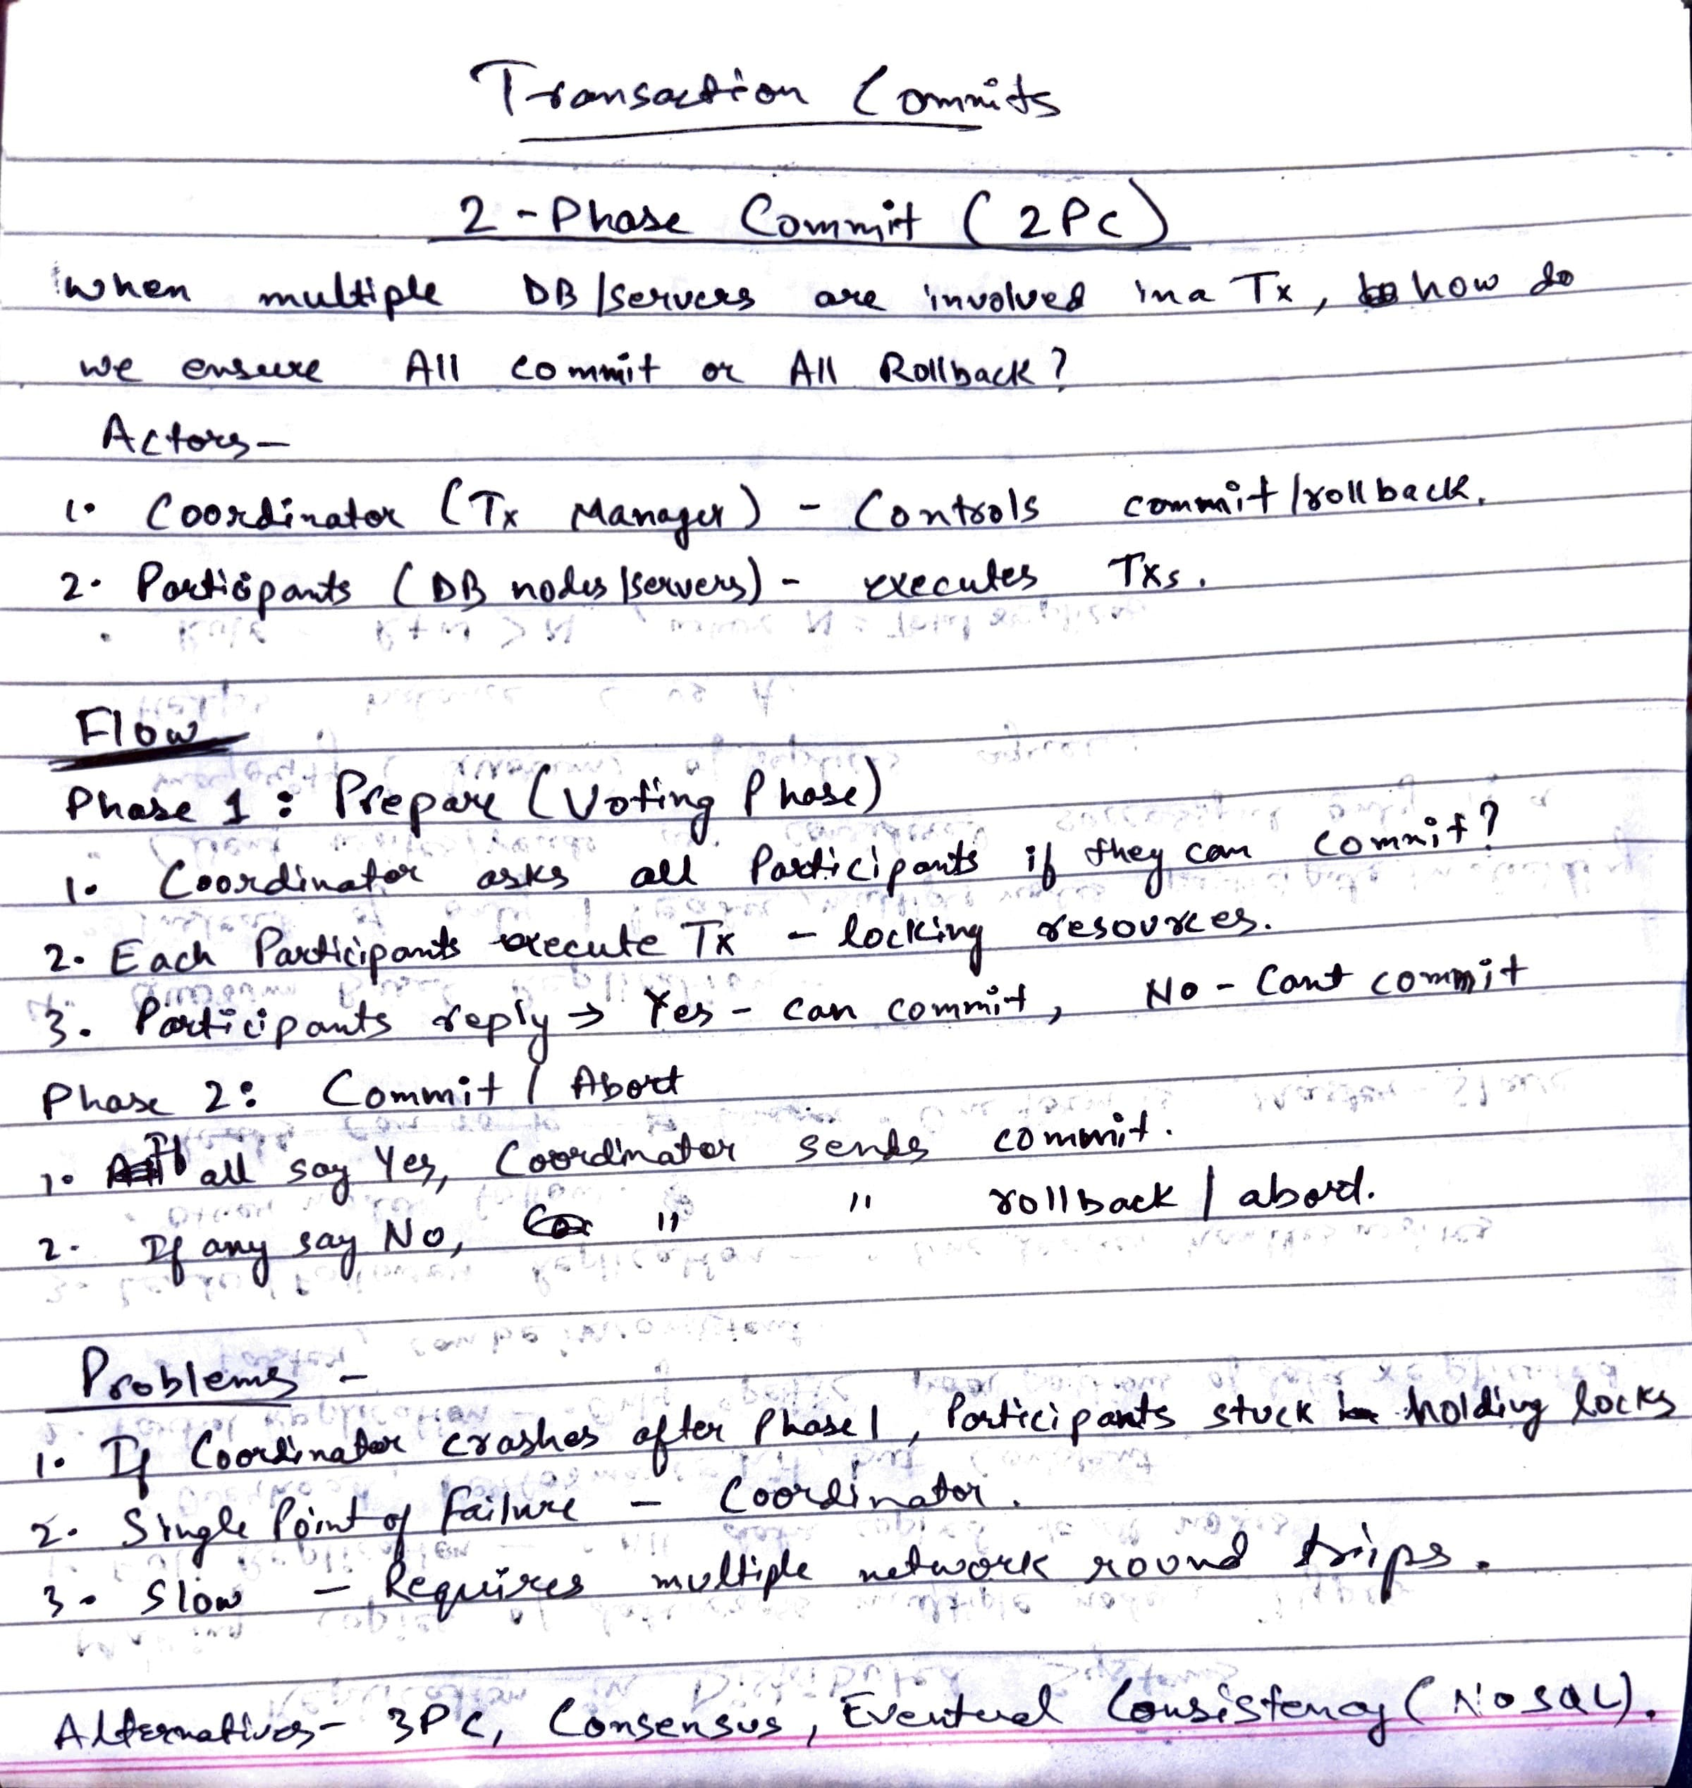

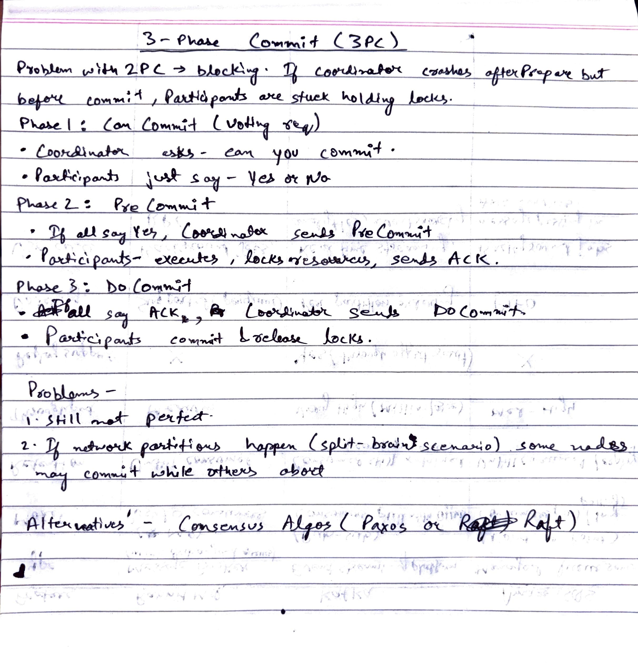

# Caching and Performance

## Caching

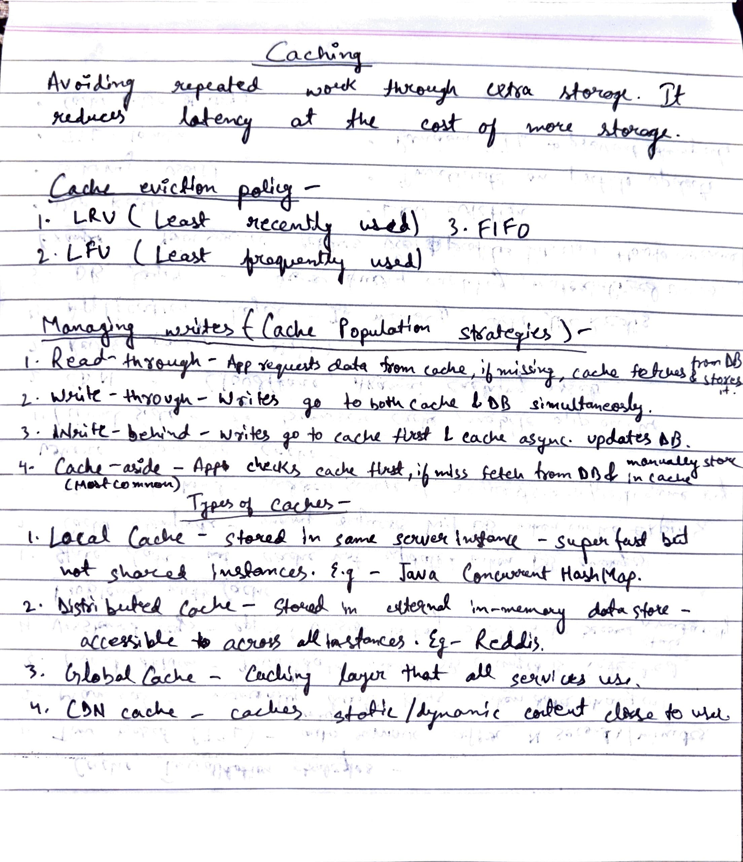

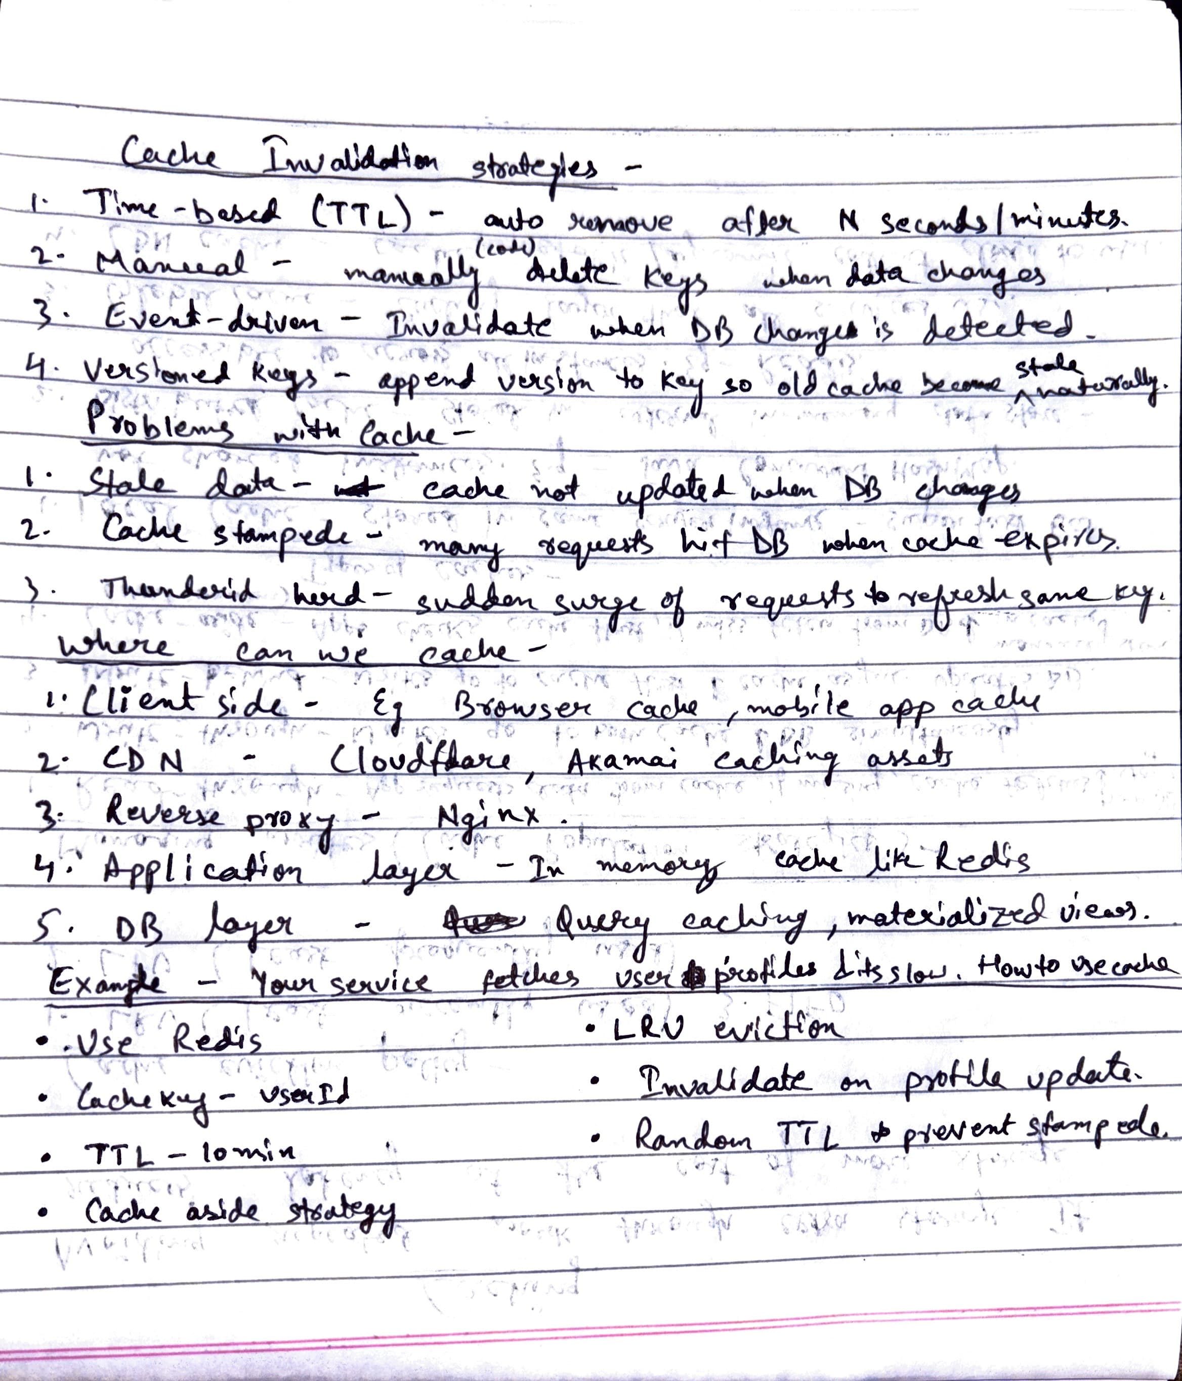

## CDN

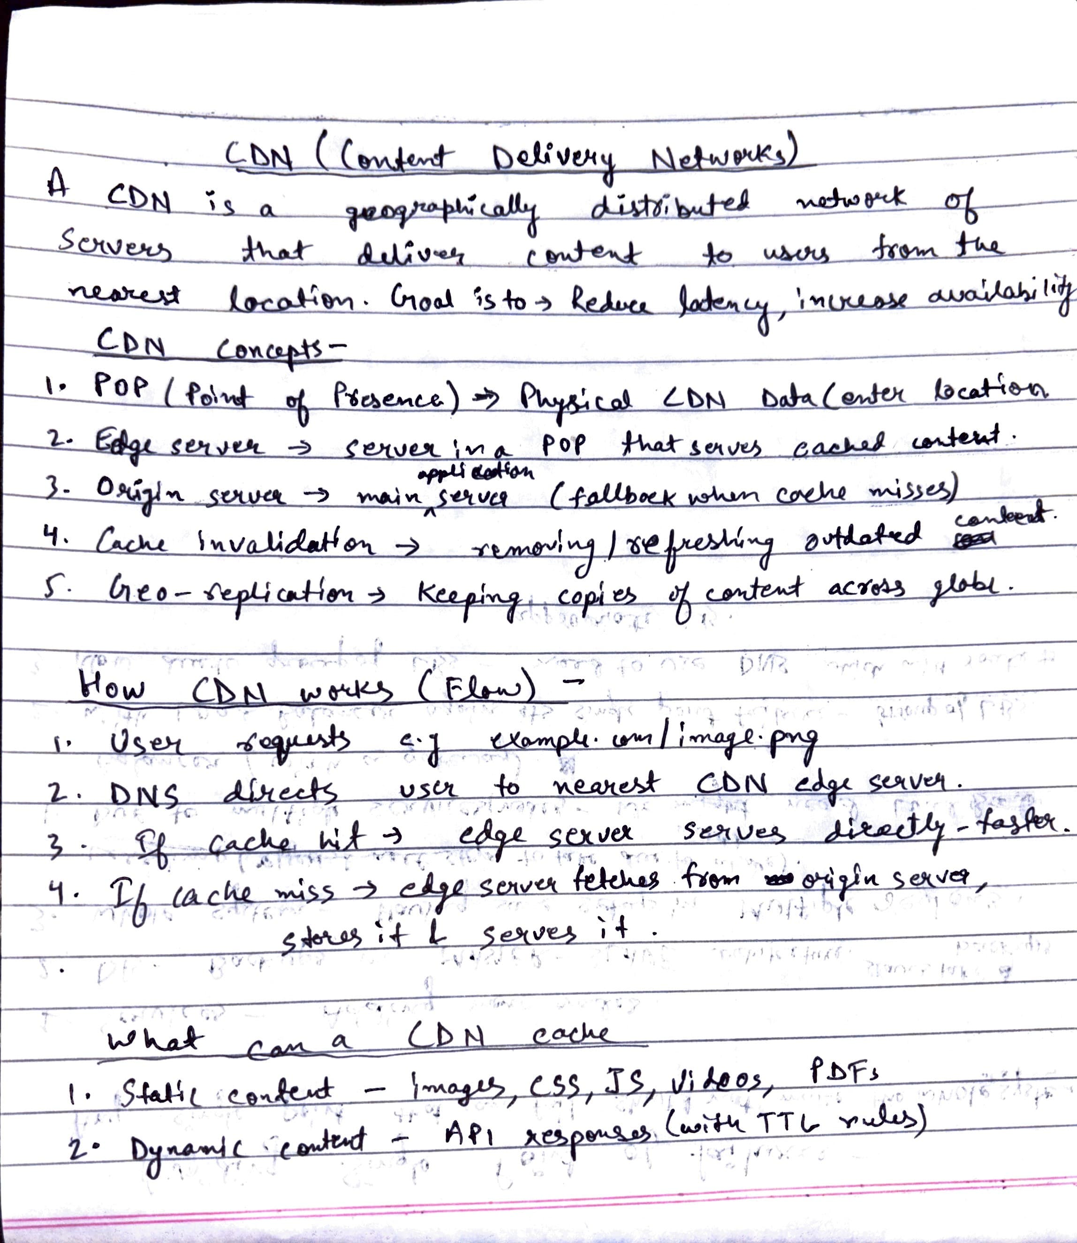

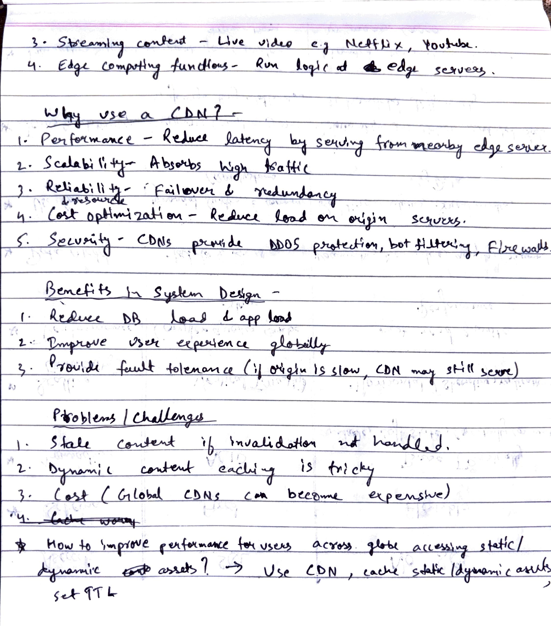

## Rate limiter

A rate limiter controls how many requests a user/system can make in a given time window.

* Prevents abuse (e.g., spam, brute-force attacks).
* Protects backend services from being overloaded.
* Ensures fair usage across users.

Common Algorithms used for Rate limiting -

1. Fixed Window Counter
   1. Divide time into fixed intervals (e.g., 1 min).
   2. Keep a counter for each user → reset every window.
   3. Pros: Simple, memory efficient.
   4. Cons: Can allow bursts at window boundaries.
   5. Example: Limit = 5 req/min. User makes 5 requests at 12:00:58
2. Sliding Window Counter
   1. Like fixed window, except for the starting point of each window.
   2. With sliding window, time frame only starts when a new request comes in, not a predetermined time.
   3. Pros: handles variable trasffic pattern better.
   4. Cons: complex & required more memory and computation.
3. Token Bucket
   1. Bucket holds tokens (capacity = limit).
   2. Tokens added at a fixed rate (e.g., 5 per second).
   3. Each request consumes a token.
   4. If request has no tokens → reject/throttle.
   5. Pros: Allows burst traffic up to bucket size, then enforces steady rate.
   6. Example: Bucket = 10 tokens, refill = 1/sec. Can burst up to 10 requests instantly. Then max 1 request/sec.
4. Leaky Bucket
   1. Similar to token bucket, but requests processed at a fixed outflow rate.
   2. Excess requests → dropped or queued.
   3. Pros: Ensures constant rate (good for traffic shaping).

Token bucket is most commonly used in industry (e.g., Google, AWS)

# Messaging and Streaming

## Message Delivery Semantics

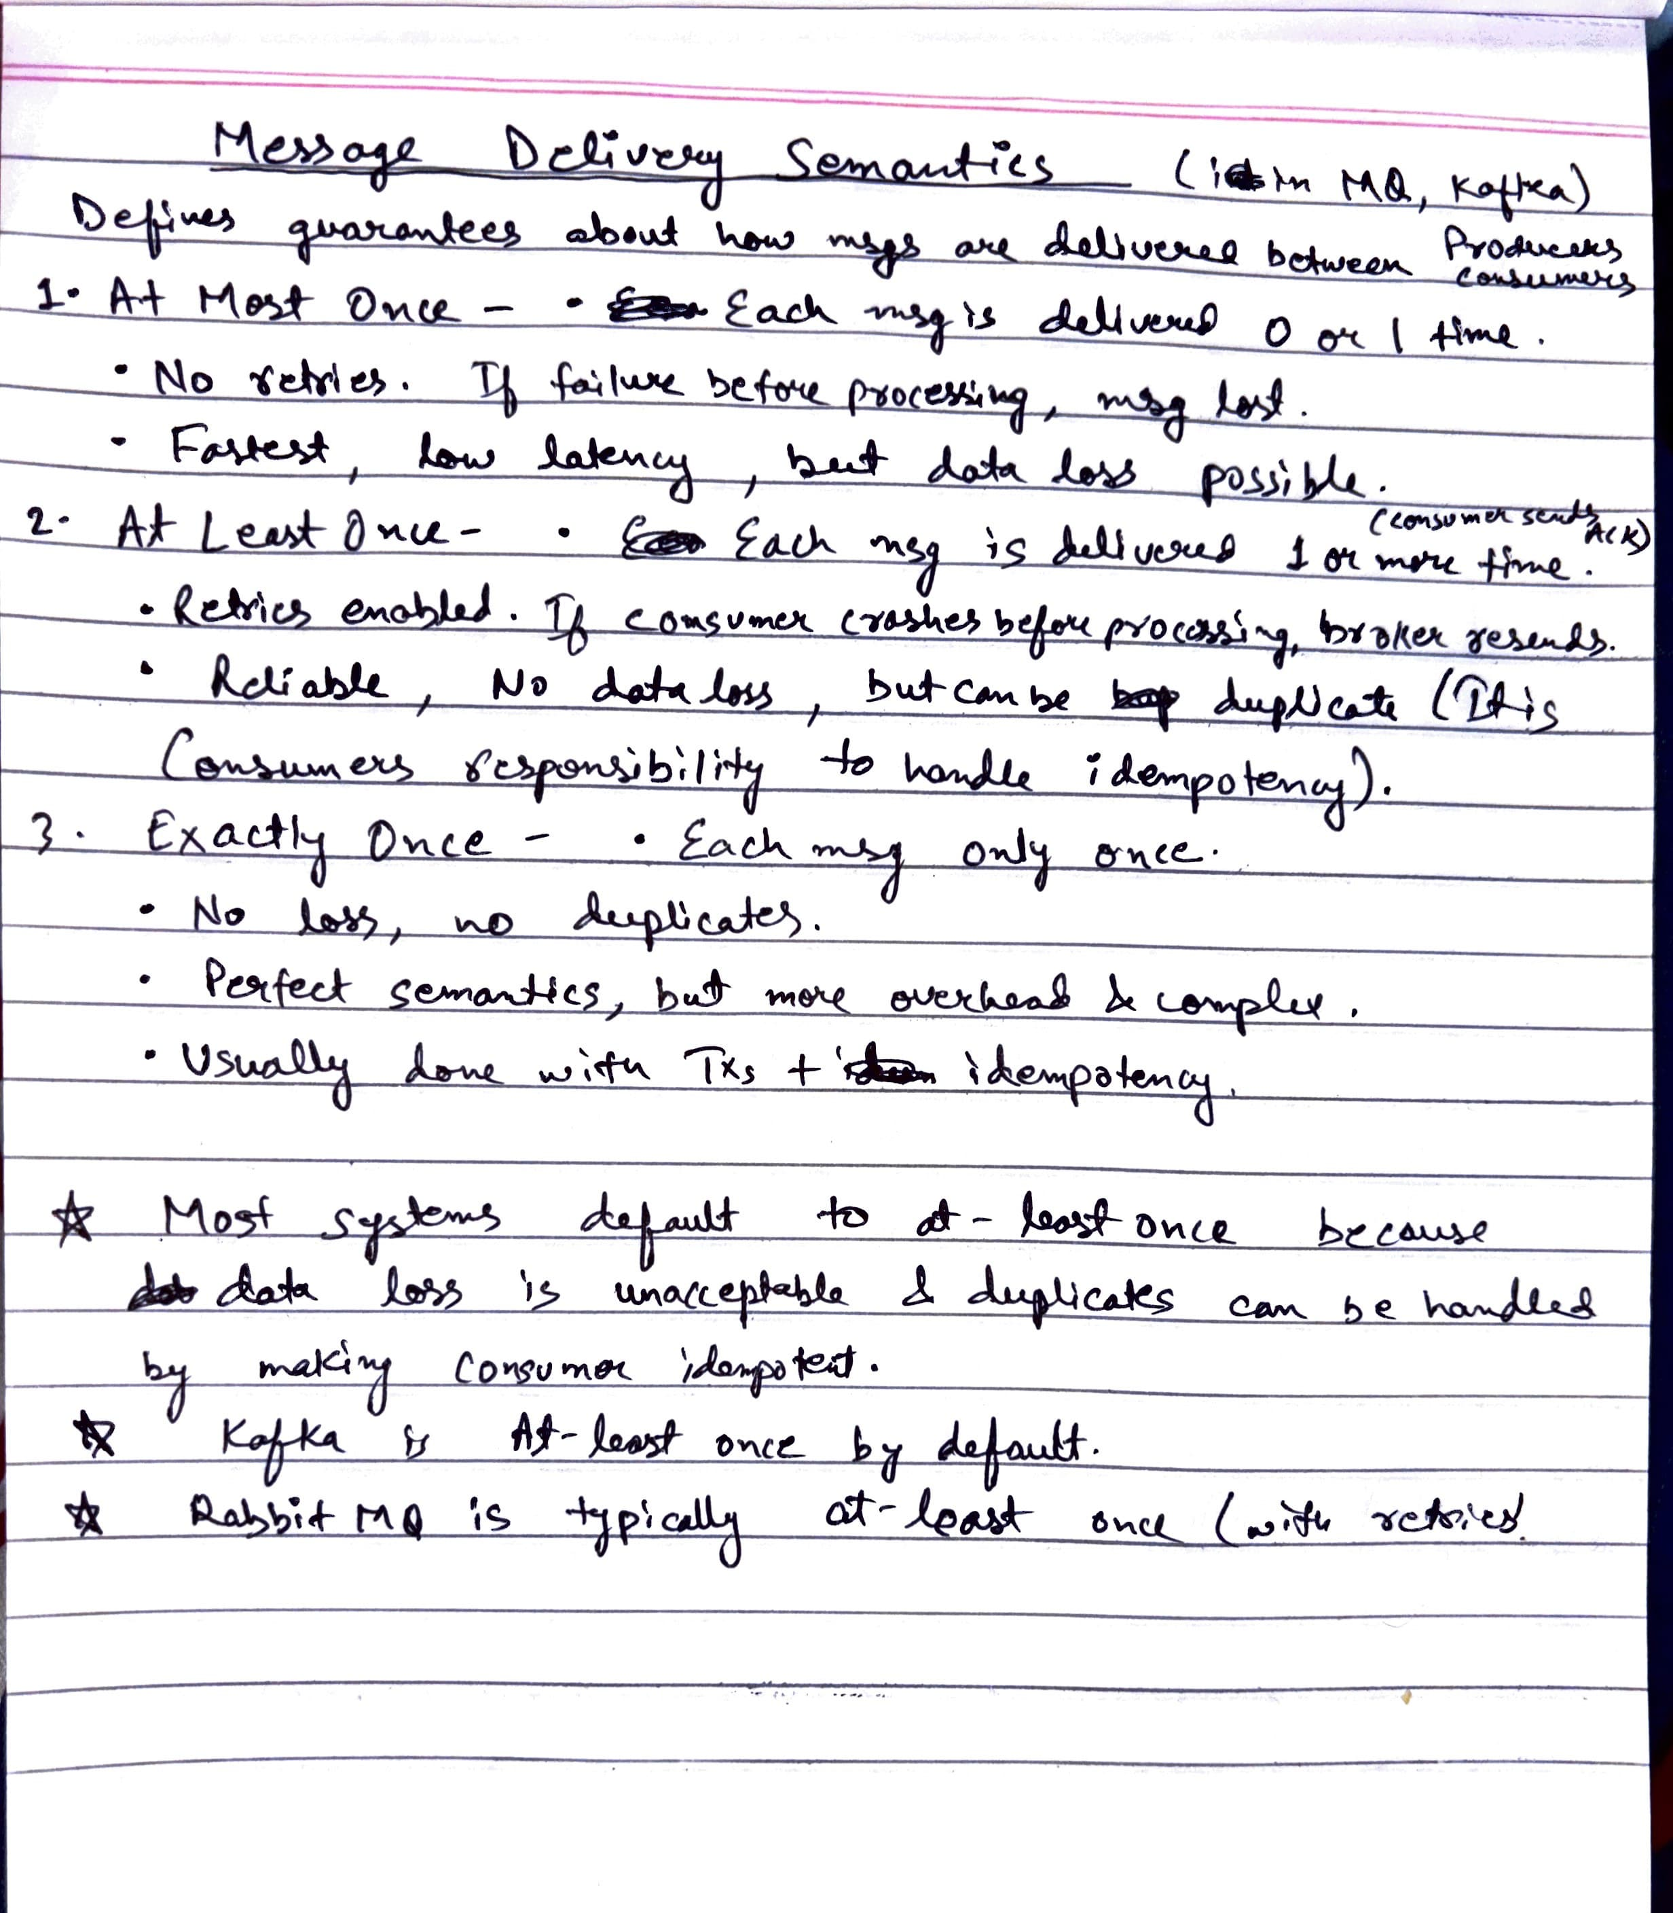

## Messaging Queues

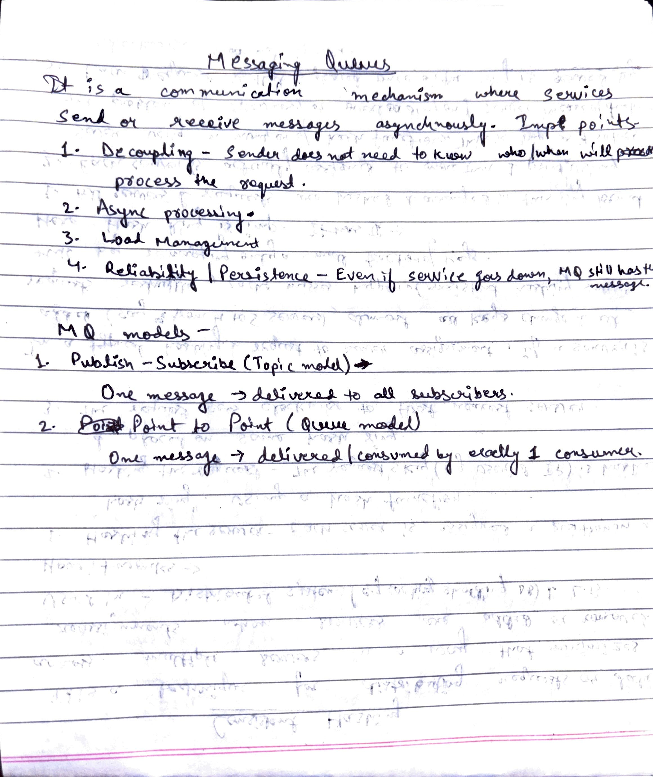

## Rabbit MQ vs Kafka vs Amazon SQS

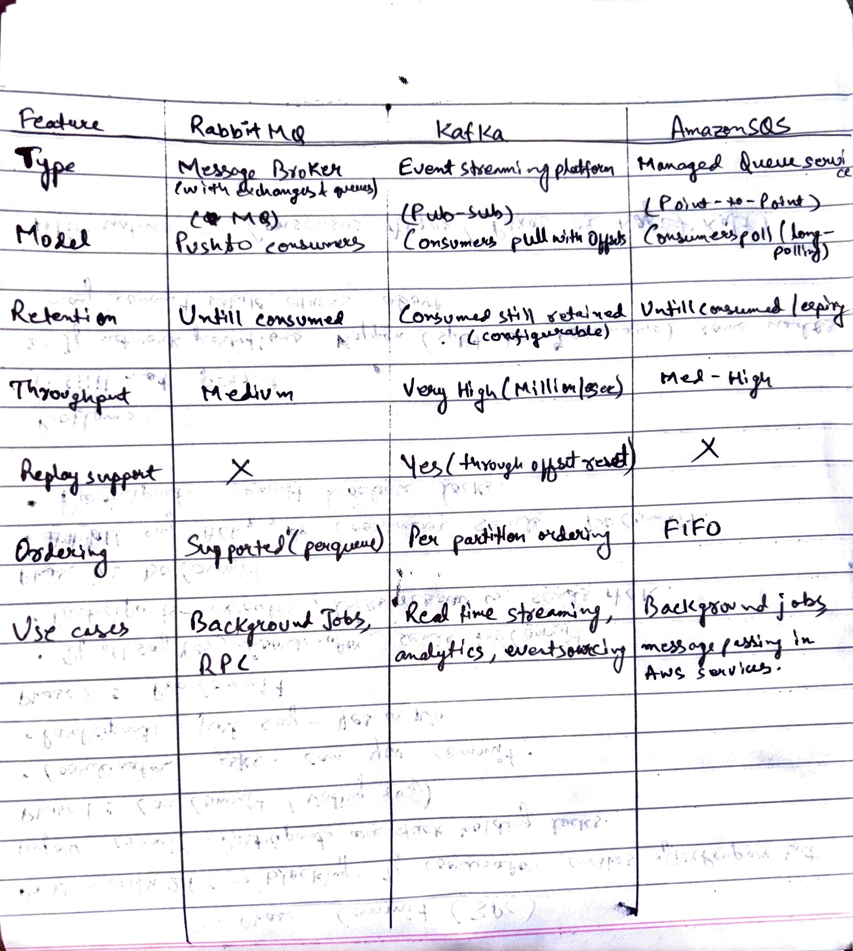

## Batch Processing vs Stream Processing

|  |  |  |
| --- | --- | --- |
| **Feature** | **Batch Processing** | **Stream Processing** |
| Data Processing | Processes a large volume of data at once. | Processes data as it arrives, record by record. |
| Latency | High latency, as processing happens after data collection. | Low latency, providing near real-time insights. |
| Throughput | Can handle vast amounts of data at once. | Optimized for real-time but might handle less data volume. |
| Use Case | Ideal for historical analysis or large-scale data transformations. | Best for real-time analytics, monitoring, and alerts. |
| Complexity | Relatively simpler to implement with predefined datasets. | More complex, requires handling continuous streams. |
| Data Scope | Operates on a finite set of data. | Operates on potentially infinite streams of data. |
| Error Handling | Errors can be identified and corrected before execution. | Requires real-time handling of errors and failures. |
| Resource Usage | Resource-intensive during processing, idle otherwise. | Continuous use of resources. |
| Cost | Cost-effective for large volumes of data. | More expensive due to continuous processing. |

# Reliability and Recovery

## Distributed Tracing

Distributed Tracing is a method to track a single request as it flows through multiple microservices in a distributed system. It helps answer:

* Where did the request spend most of the time?
* Which service is slow?
* Where did the failure happen?

Why Do We Need It?

* In monoliths, debugging is easy because everything is in one process.
* In microservices, a single request may pass through 10–20 services. Without tracing, finding bottlenecks is very hard.

How It Works

1. Unique Trace ID
   1. Every request is assigned a trace ID (e.g., UUID).
   2. This trace ID is passed along all services handling the request (usually via HTTP headers).
2. Span
   1. Each service creates a span → representing its work (start time, end time, metadata). Example: PaymentService span = 200ms.
3. Trace
   1. A trace = collection of spans across services for one request.

## Disaster Recovery (DR)

Disaster Recovery is the strategy and set of processes a system uses to recover and continue operations after a catastrophic failure. Failures could be due to: Natural disasters (earthquake, flood, fire), Data center outage, Network failure, Cyber attacks or accidental data deletion.

Key Metrics in DR

1. RPO (Recovery Point Objective) - Maximum acceptable data loss (measured in time). Example: RPO = 5 mins → system should be able to restore data up to 5 mins before the failure.
2. RTO (Recovery Time Objective) - Maximum acceptable downtime after a disaster. Example: RTO = 1 hour → system must be back online within 1 hour.

Disaster Recovery Strategies

1. Backup & Restore
   1. Regularly back up data to remote storage.
   2. Restore when disaster occurs.
   3. Pros: Cheap.
   4. Cons: Very high RTO (slow recovery).
2. Pilot Light
   1. Keep a minimal version of your system running in another region (only core services).
   2. In case of disaster, scale it up quickly.
   3. Balance between cost and recovery speed.
3. Warm Standby
   1. Keep a smaller but fully functional copy of the system running in another region.
   2. It handles some traffic but can scale up during disaster.
   3. RTO and RPO are moderate.
4. Hot Standby / Active-Active
   1. Two (or more) full systems run in parallel in different regions.
   2. If one goes down, traffic is instantly redirected.
   3. Pros: Very low RTO and RPO.
   4. Cons: Expensive.

Techniques Used in DR

1. Data Replication (synchronous vs asynchronous).
2. Failover Mechanisms (automatic DNS switching, load balancer failover).
3. Geo-Redundancy (multiple regions).
4. Chaos Engineering (test recovery by intentionally causing failures).

Important Links –

<https://www.linkedin.com/posts/ashishps1_how-i-would-learn-system-design-fundamentals-activity-7181881895985528832-OA7Q?utm_source=li_share&utm_content=feedcontent&utm_medium=g_dt_web&utm_campaign=copy>